**Final Project**

**Predicting the Effects of Earthquakes Using Cloud-Based Machine Learning**

**Team Members:**



**Project Description:**

The goal of this project, "Predicting the Effects of Earthquakes Using Cloud-Based Machine Learning," is to create prediction models for earthquake features by utilizing PySpark and AWS SageMaker. Improving seismic event predicting and showcasing the effectiveness of cloud technology in handling and evaluating massive datasets are the main goals. The desired results include enhanced readiness for earthquakes and the capacity to react quickly to any seismic hazards by using reliable and accurate machine learning forecasts.

**Scope:**

The scope of this project includes building and implementing machine learning models with a focus on seismic event prediction using PySpark and Amazon SageMaker. Large seismic data sets are handled efficiently by the project by utilizing AWS cloud services, such as S3 for data storage and EC2 for processing power. Machine learning processes are made scalable and reliable by using SageMaker for model deployment and use of PySpark for data preparation and model training. Additionally, this project examines how to integrate AWS Lambda for possible real-time data processing, which might improve the system's ability to react to seismic activity in real time.

**Requirements:**

For this project, AWS's cloud computing services like EC2, S3, and Lambda, as well as PySpark for data processing and Amazon SageMaker for model deployment are required. For development and testing, Jupyter Lab is a crucial tool, as are other Python libraries for data processing and show, such NumPy, pandas, and Matplotlib. High-performance computer resources are also required for the project to manage the massive amounts of data processing and analytics needed for earthquake prediction.

**Architecture:**

**Data Management and Storage:** Raw and processed seismic data are stored on Amazon S3, which serves as the main data repository.

**Data Pre-Processing and Model Development:**

PySpark on AWS EC2: PySpark is run on EC2 instances to take use of its distributed computing resources for effective data processing and model training.

**Model Management and Deployment:** The machine learning models that have been trained go into production using AWS SageMaker.

**Introduction:**

The goal of this project is to accurately predict earthquake characteristics by utilizing PySpark and Amazon SageMaker. The project makes optimal use of cloud computing to collect and analyze massive amounts of seismic data by deploying these technologies on AWS. Enhancing earthquake prediction, improving disaster response systems, and showcasing the effectiveness and scalability of cloud-based data processing are the main goals. This project is significant because it shows how modern methods of machine learning may be used in real-world situations to reduce the risks connected with natural catastrophes, which has major implications for preparedness and safety.

**Workflow Diagram:**

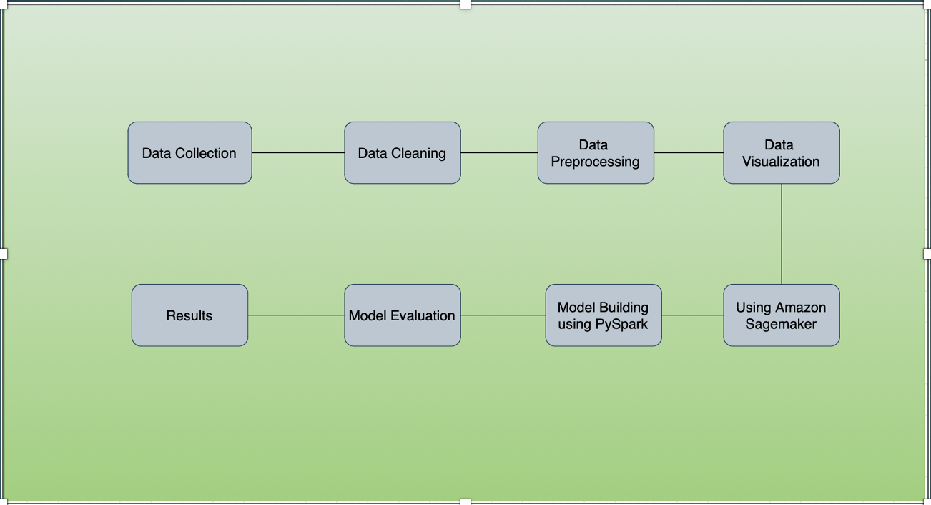

**Dataset Description:**

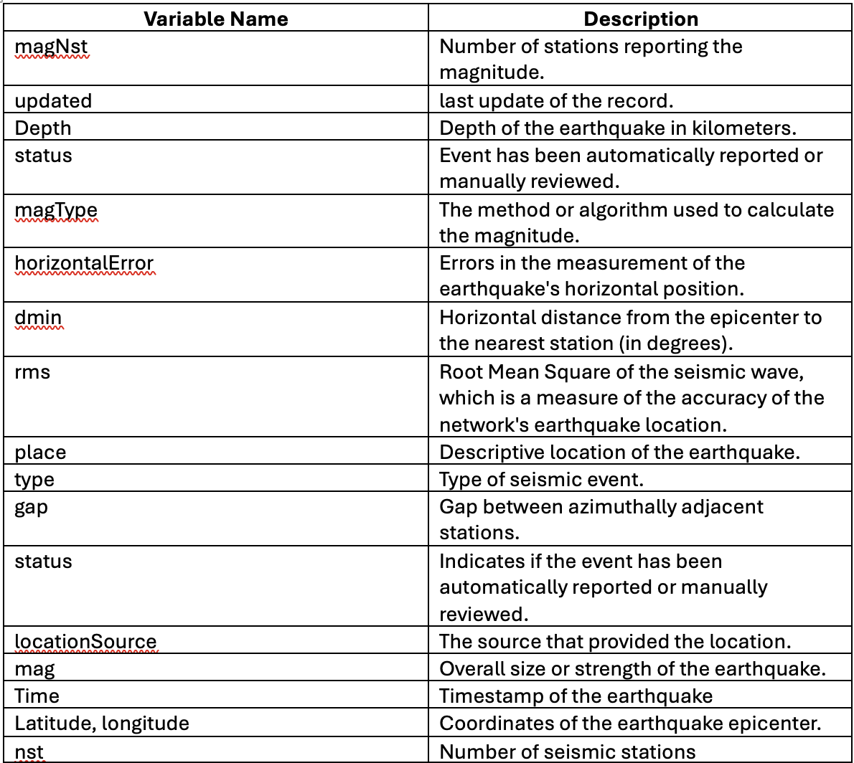

**Cloud Technologies and Services Used:**

This project provides a full featured cloud computing environment by using a variety of Amazon Web Services (AWS). **PySpark** is used to run complex algorithms for machine learning in an effective manner because to the scalable computing facilities provided by Amazon EC2. Amazon S3, which provides reliable and safe data storage solutions, handles data management and storage. With its capabilities for simple scaling and real-time analytics, **Amazon SageMaker** is a vital resource for installing, tracking, and controlling machine learning models. The project's ability to handle seismic data as it comes in is further improved by the optional use of AWS Lambda, which enables the execution of code in response to real-time data triggers.

**Project Implementation:**

**Creating an S3 bucket**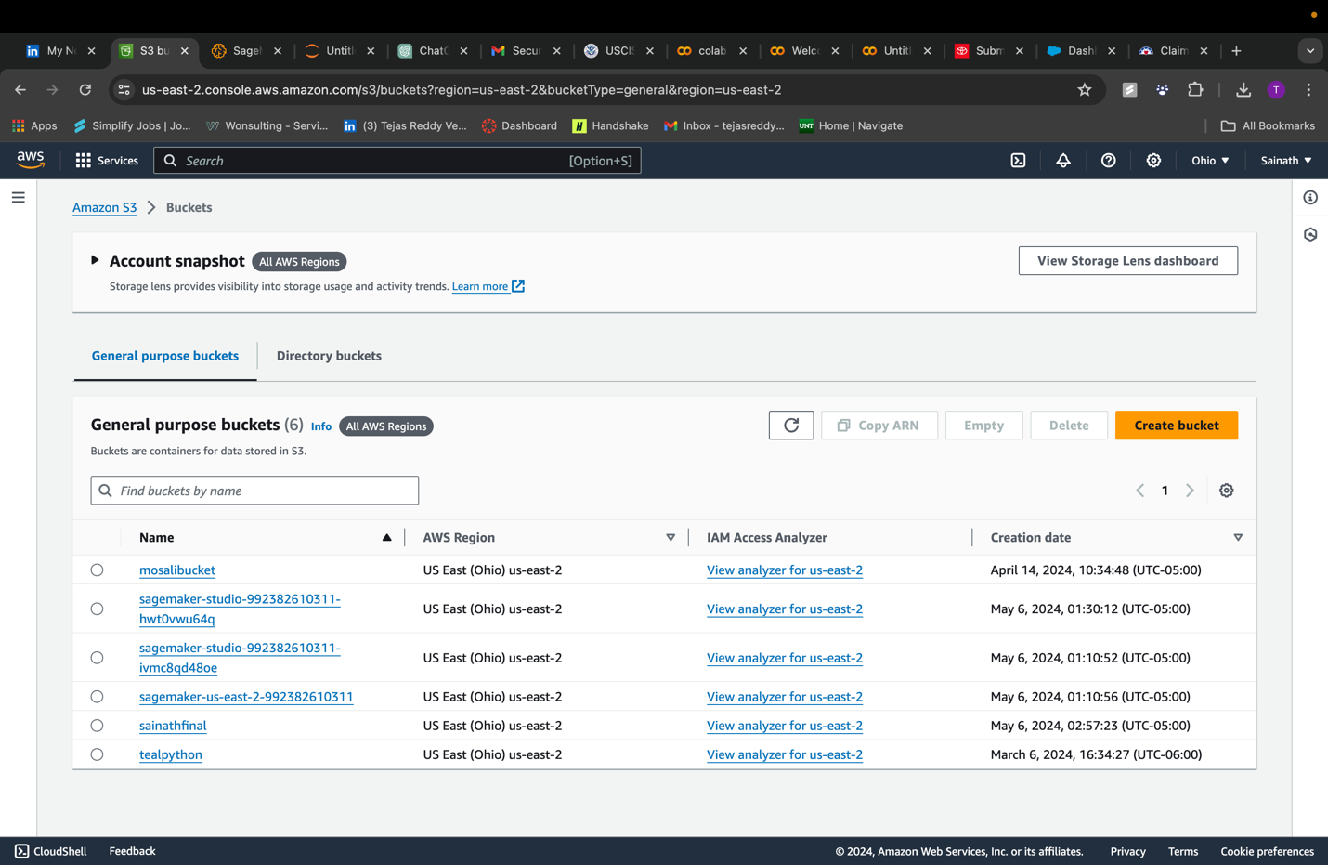using amazon sagemaker to create an instance to deploy ML models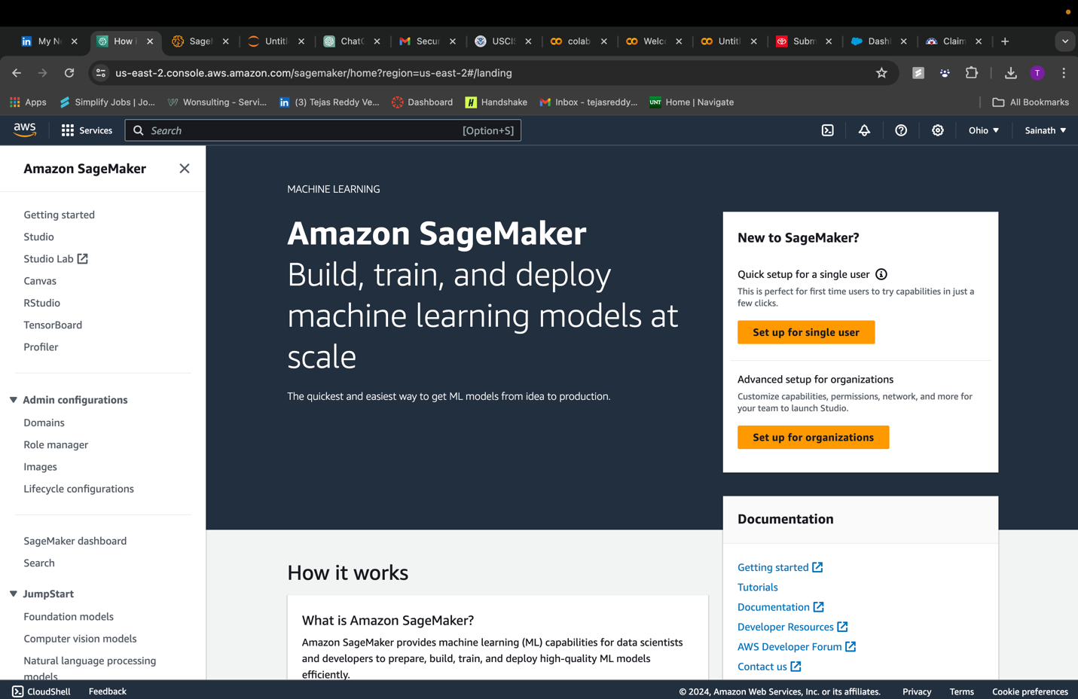setting up the domain to work in jupyter hub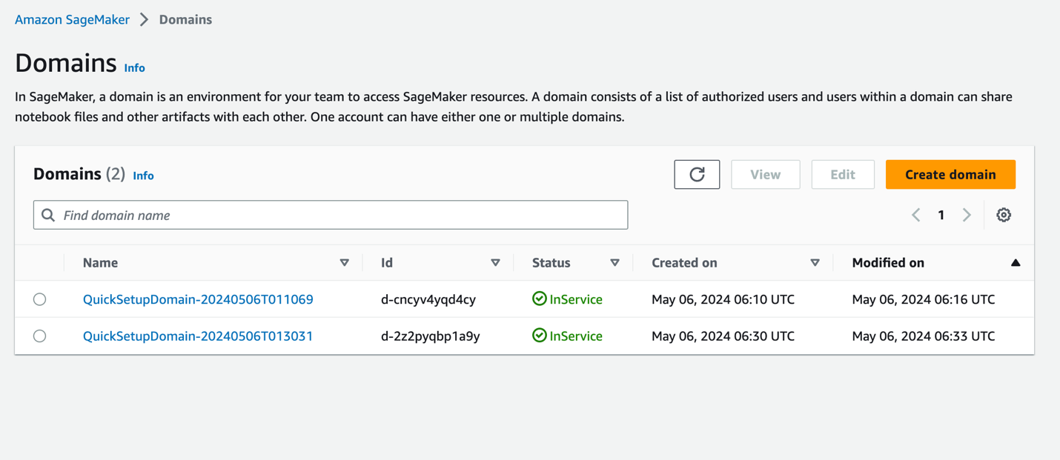launching the studio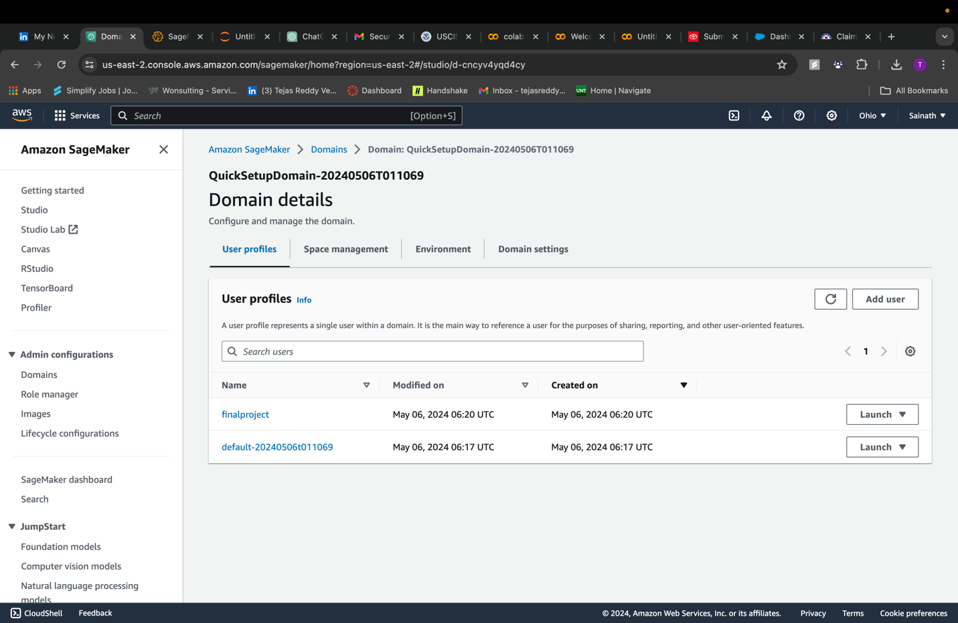open jupyter lab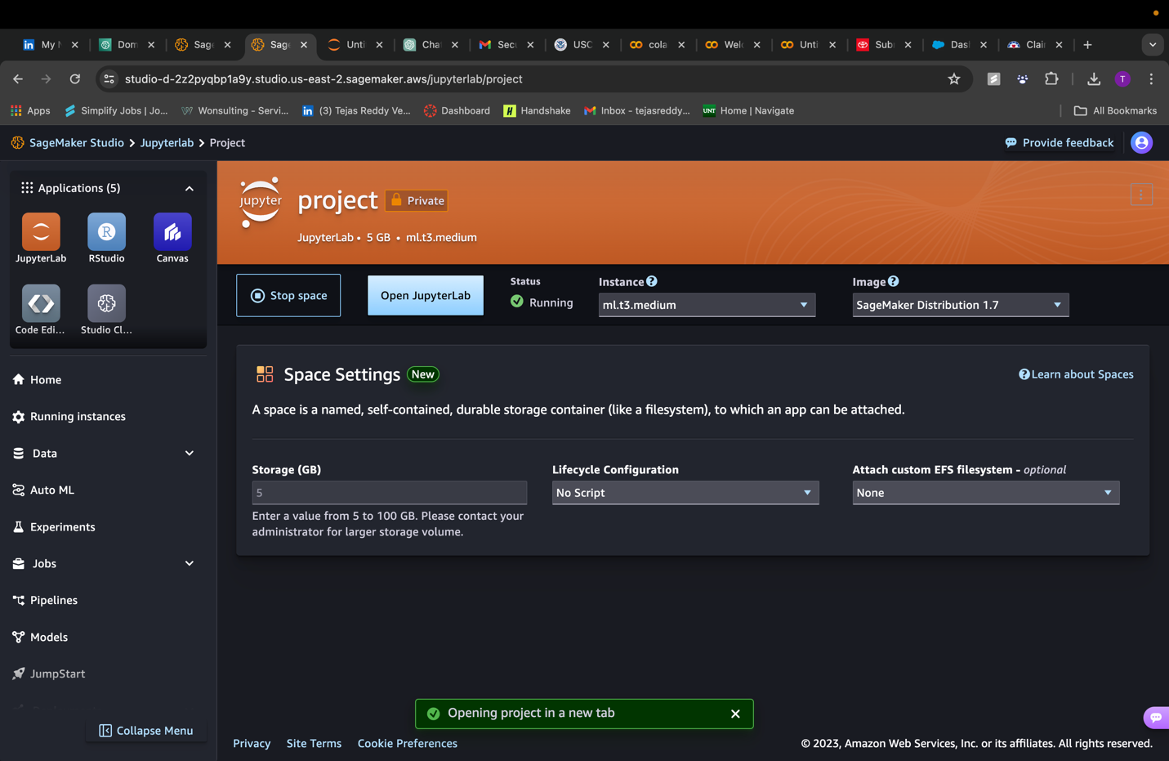

Importing and installing required packages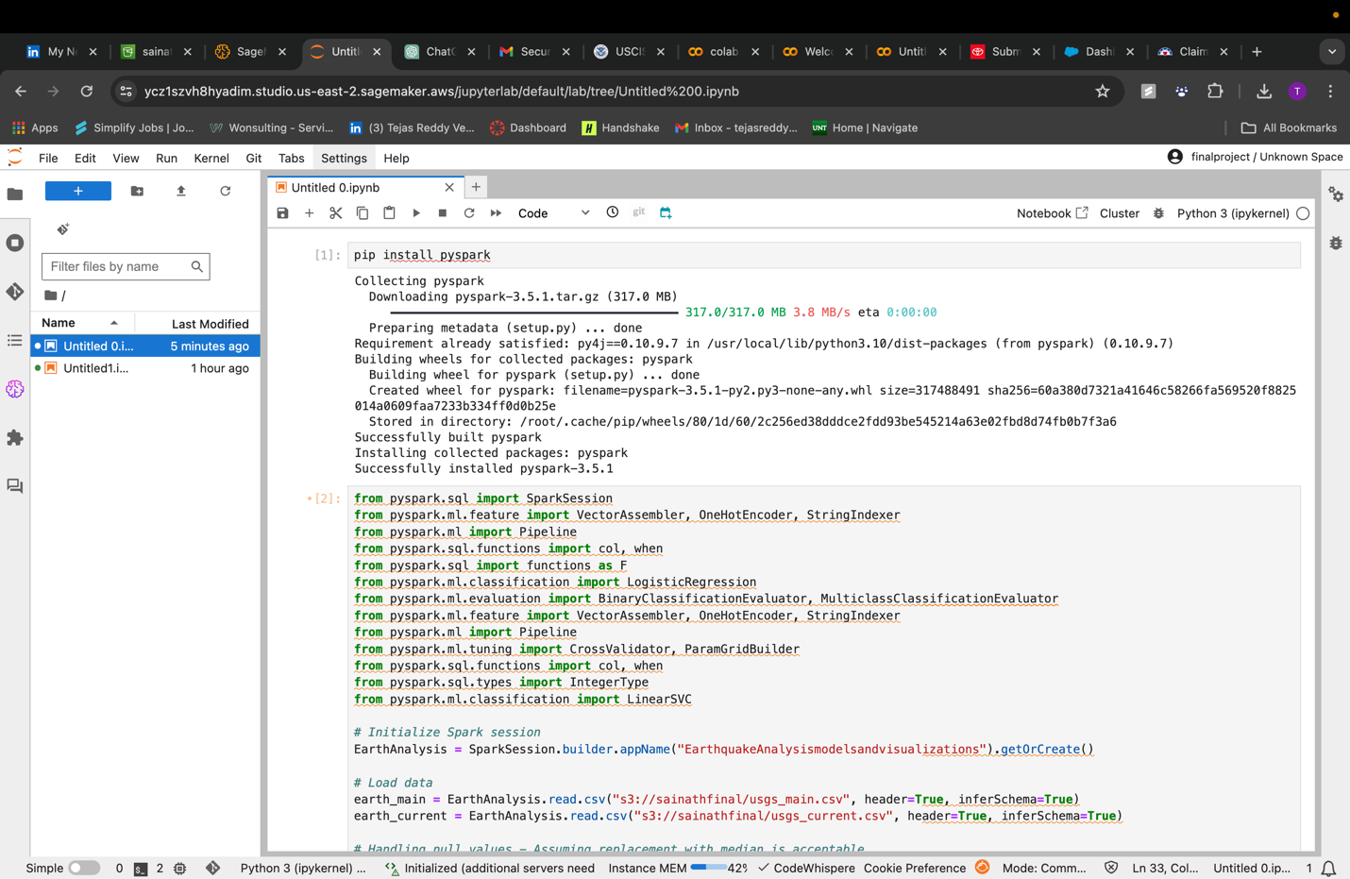retrieving data from s3 bucket and creating a SVM (support vector machine) model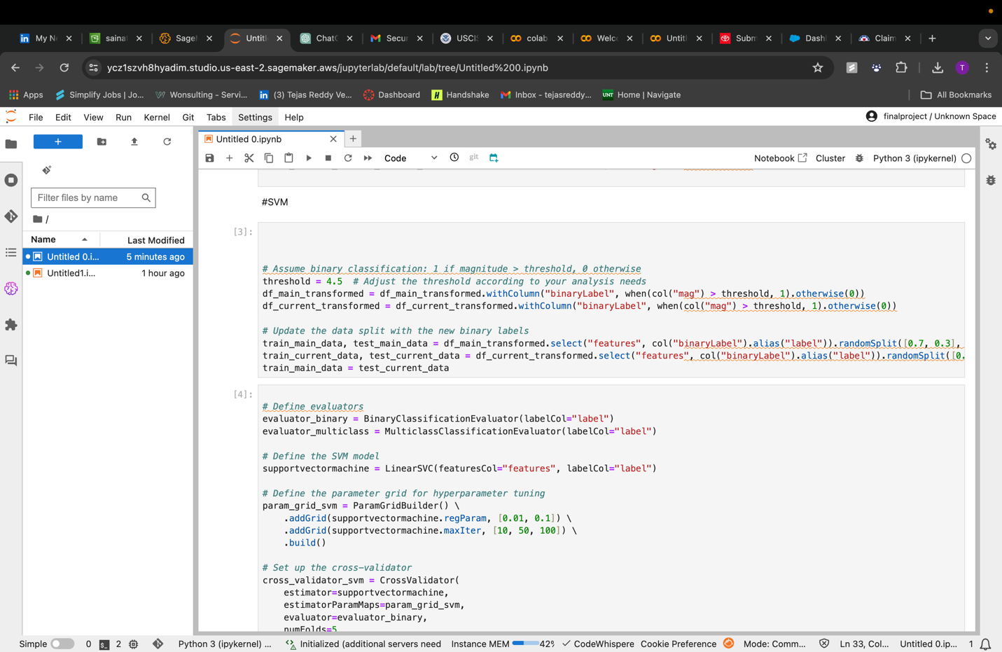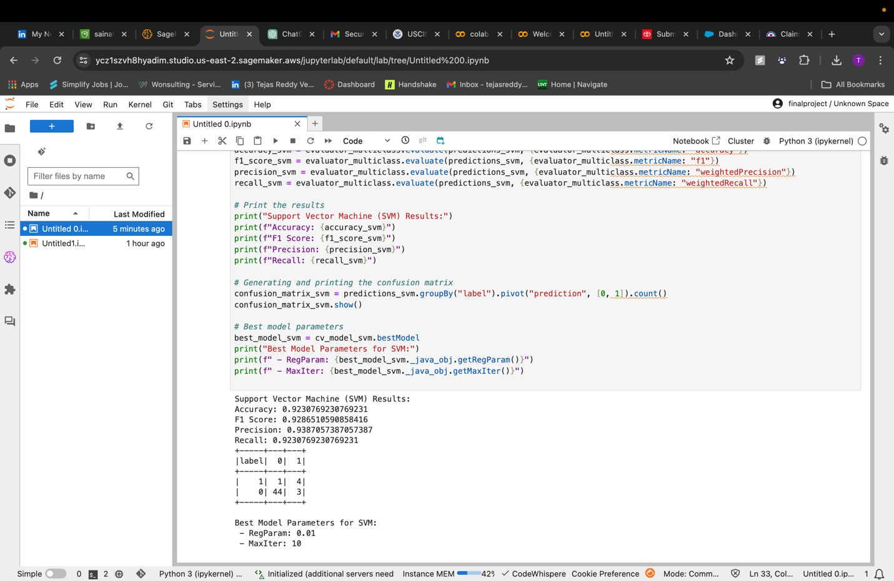

**Results:**

**SVM results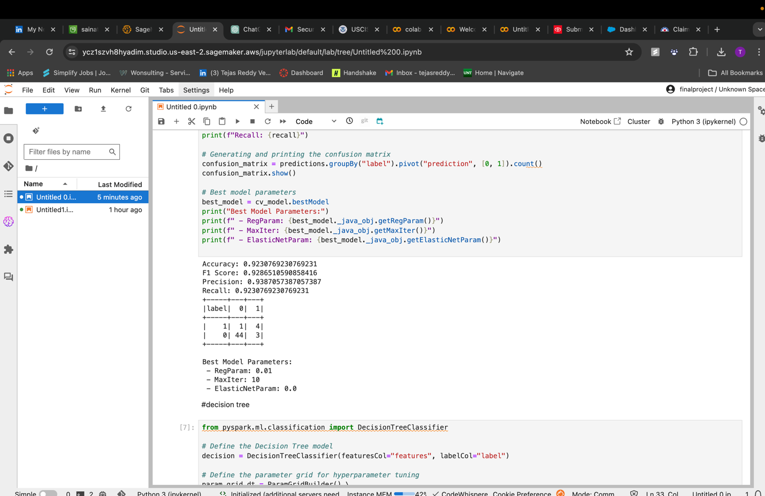Desion tree results**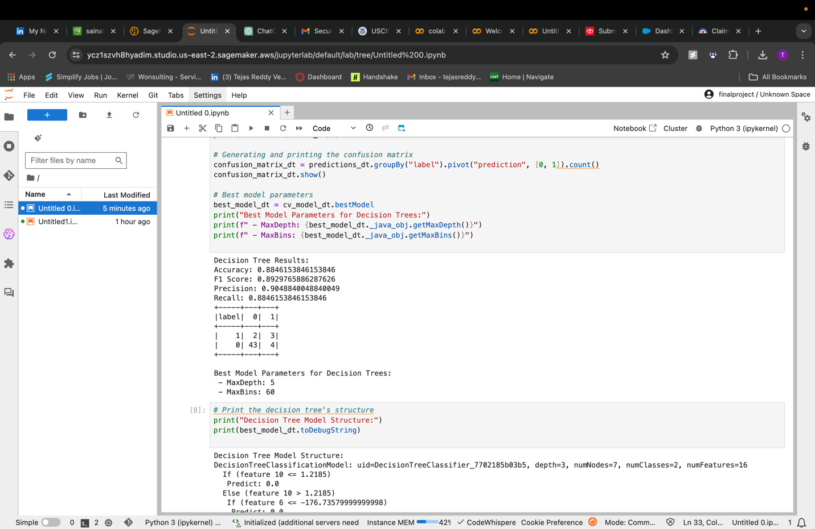

decision tree structure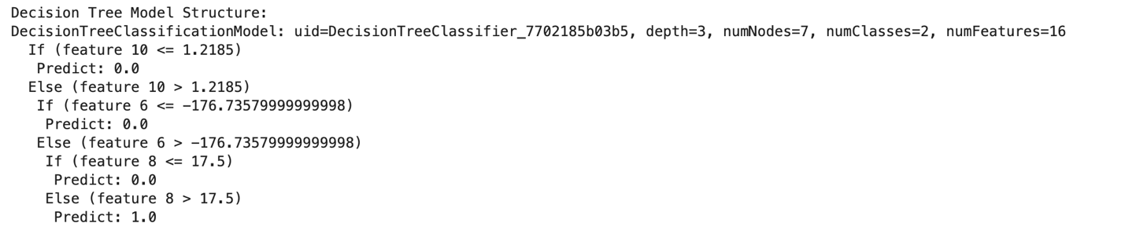random forest results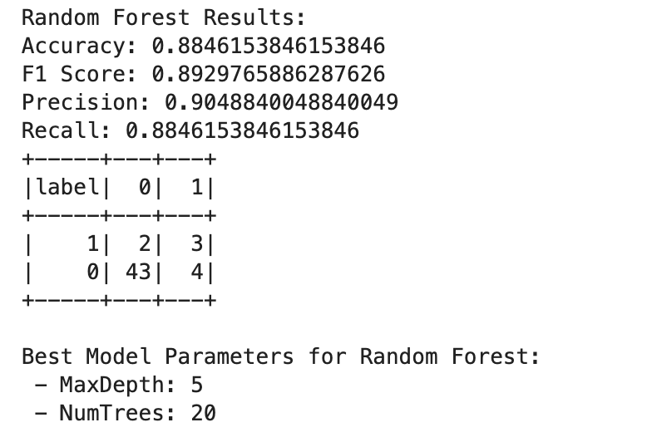

printing the importance of the features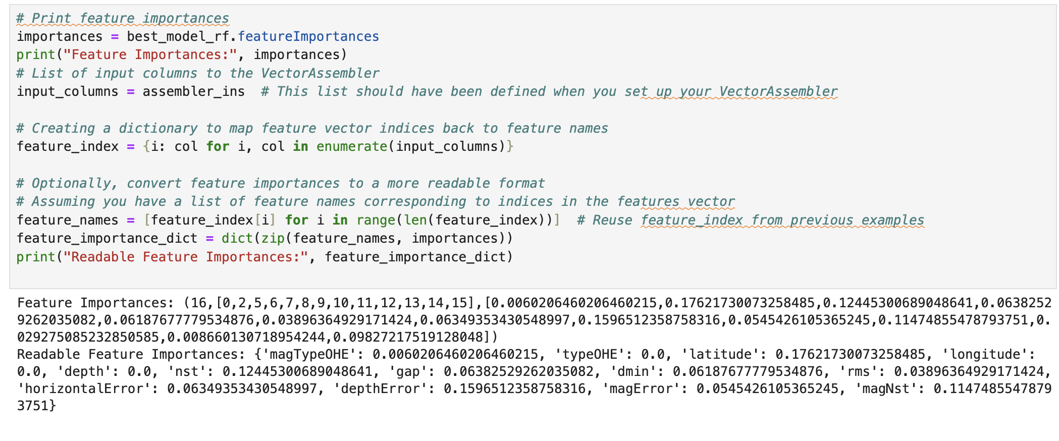Linear Regression plots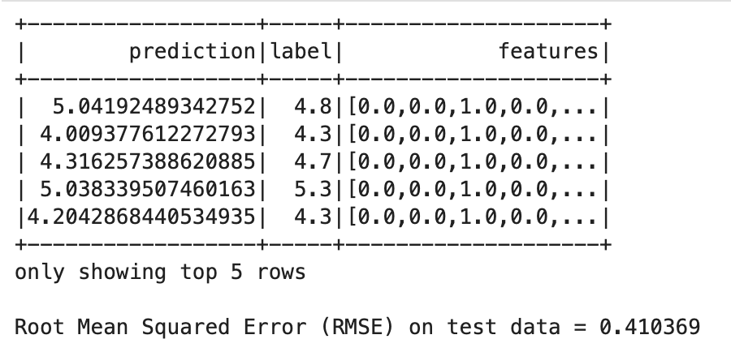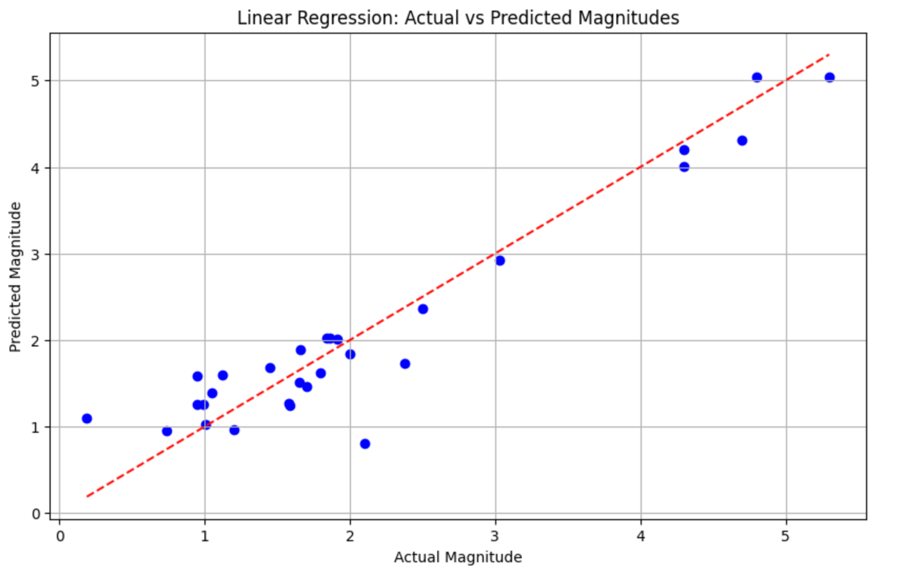random forest plots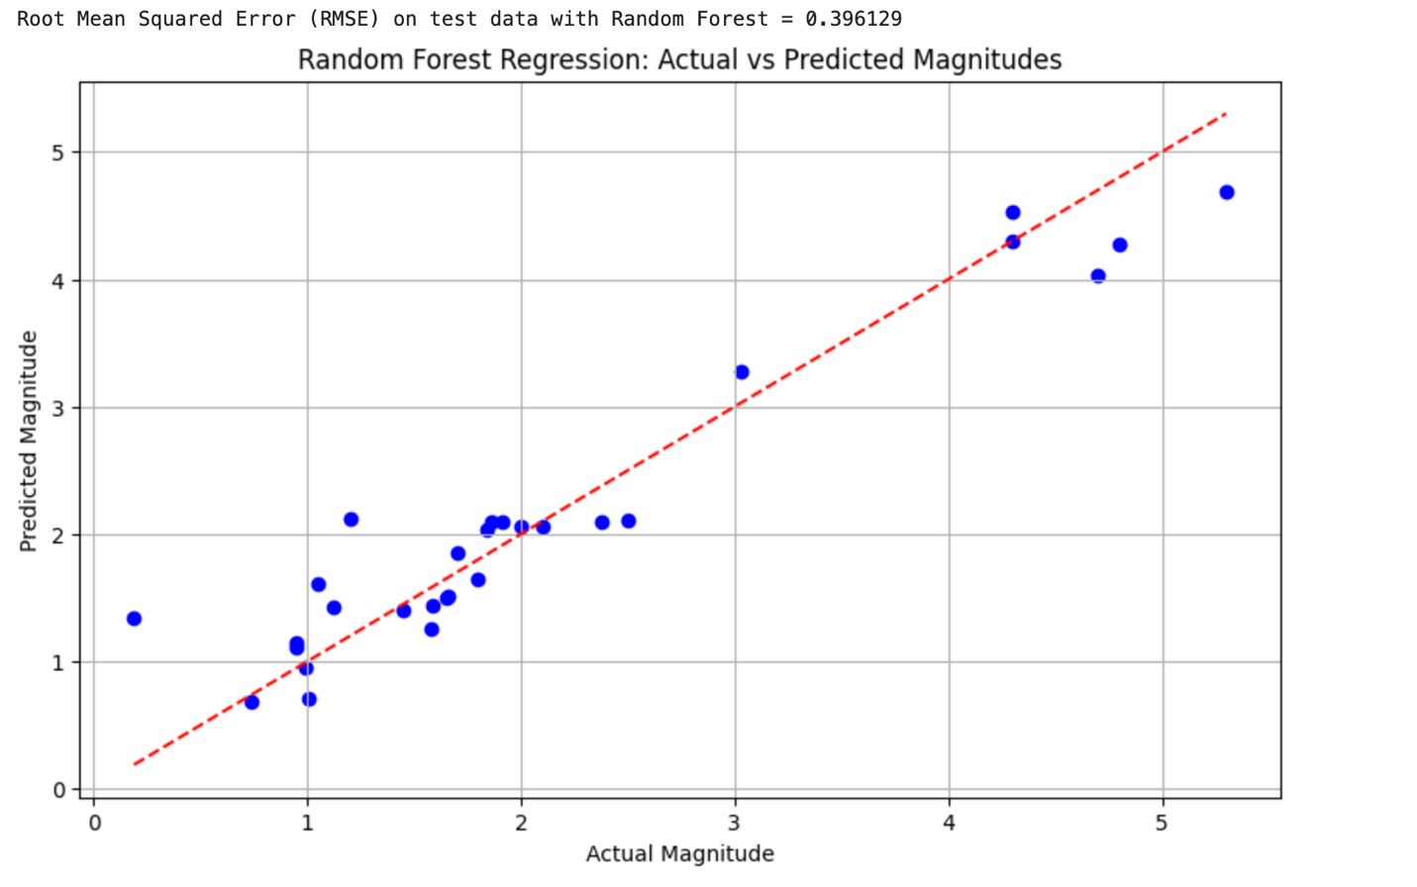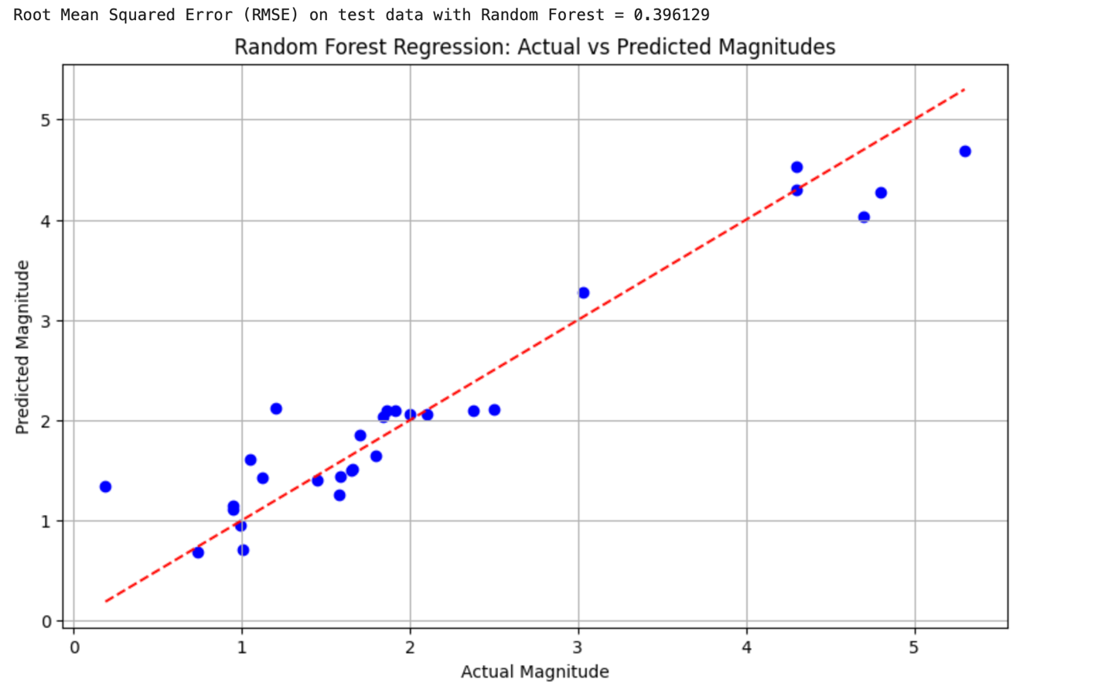

**Data Visualization:**

type of event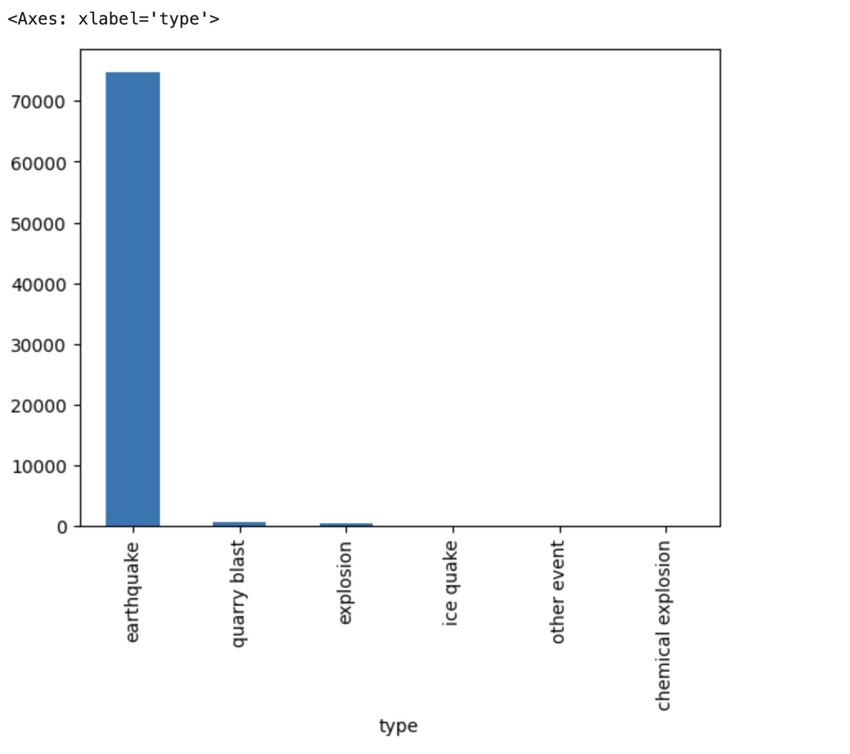place vs event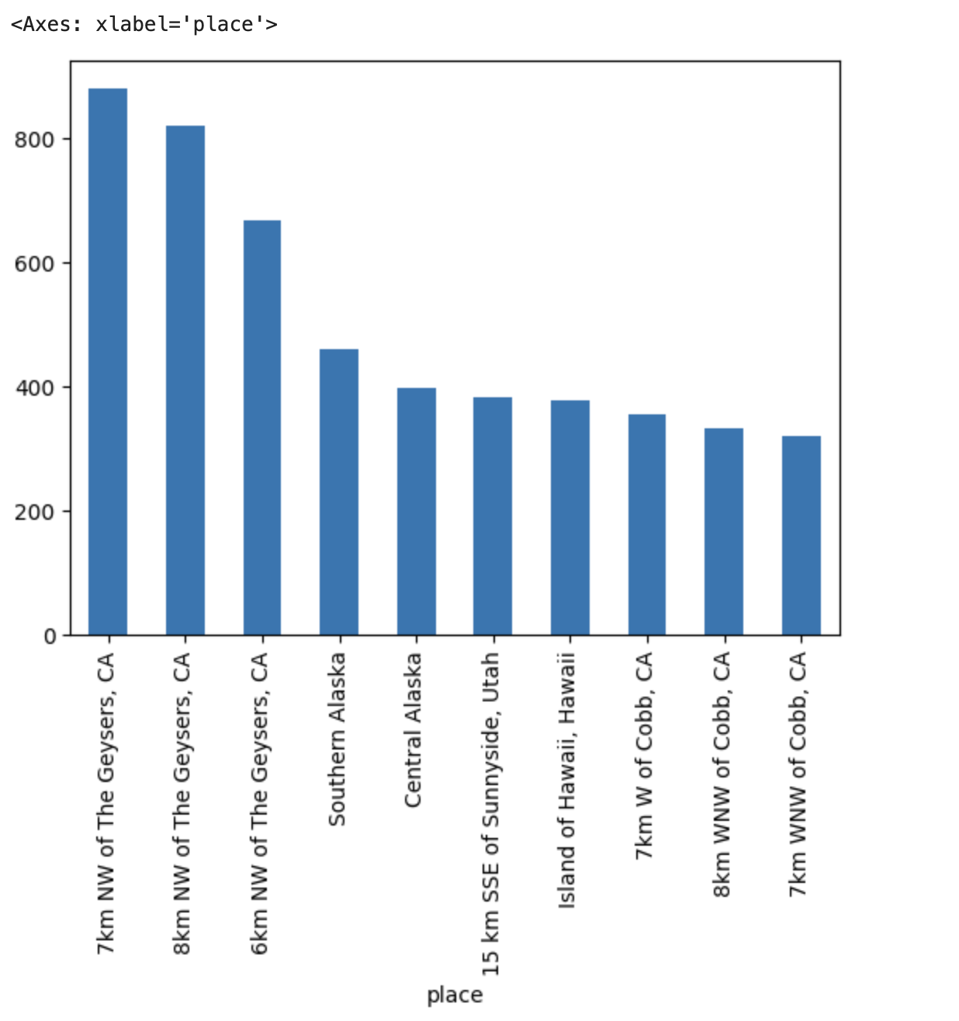longitude vs latitude to show location worldwide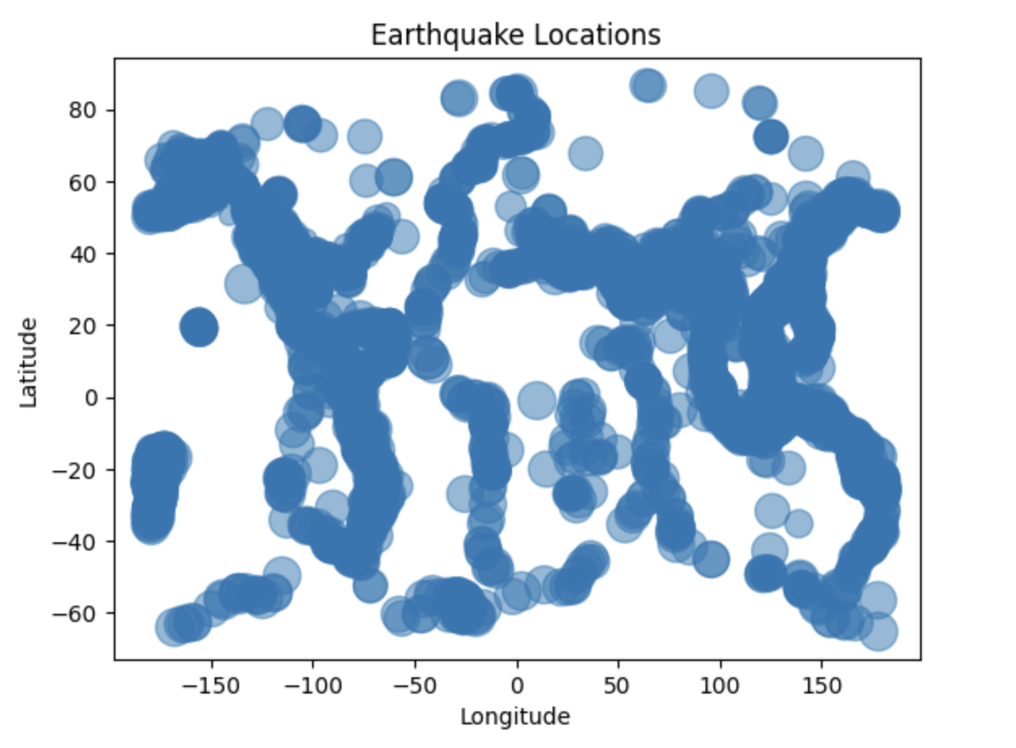Time vs number of earthquakes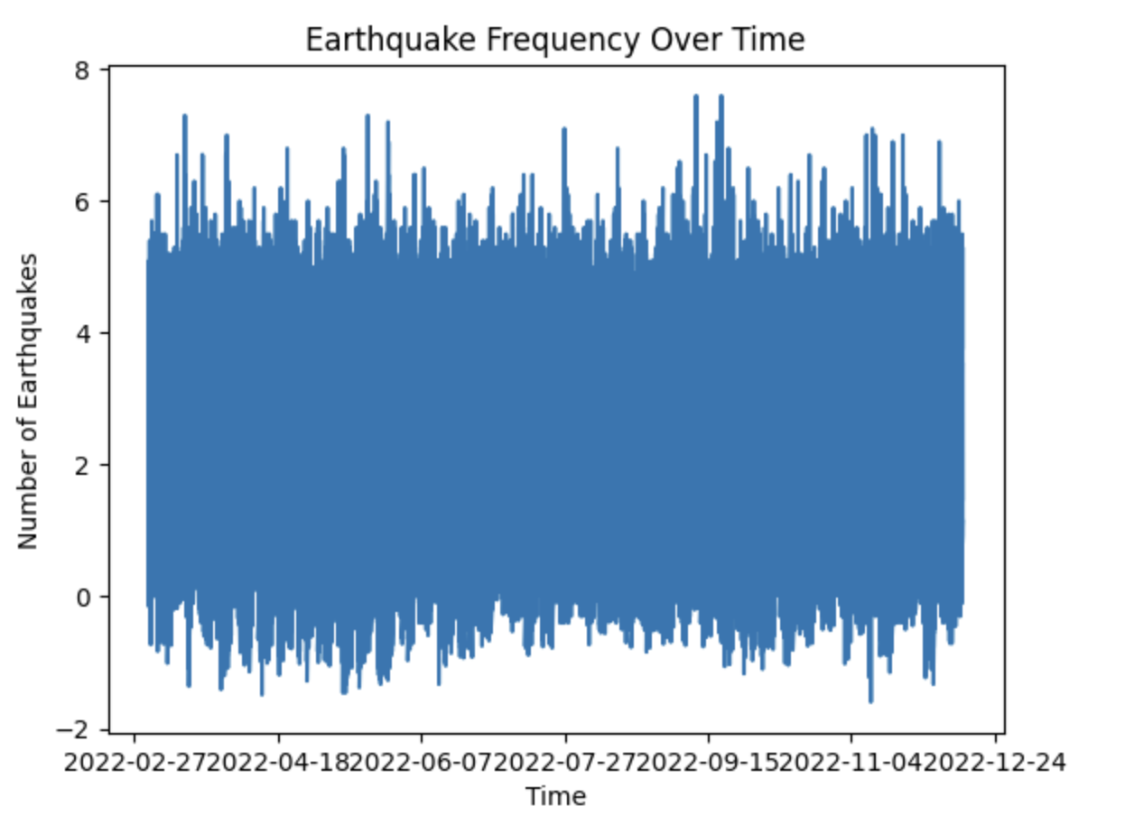Earthquake counts by location and time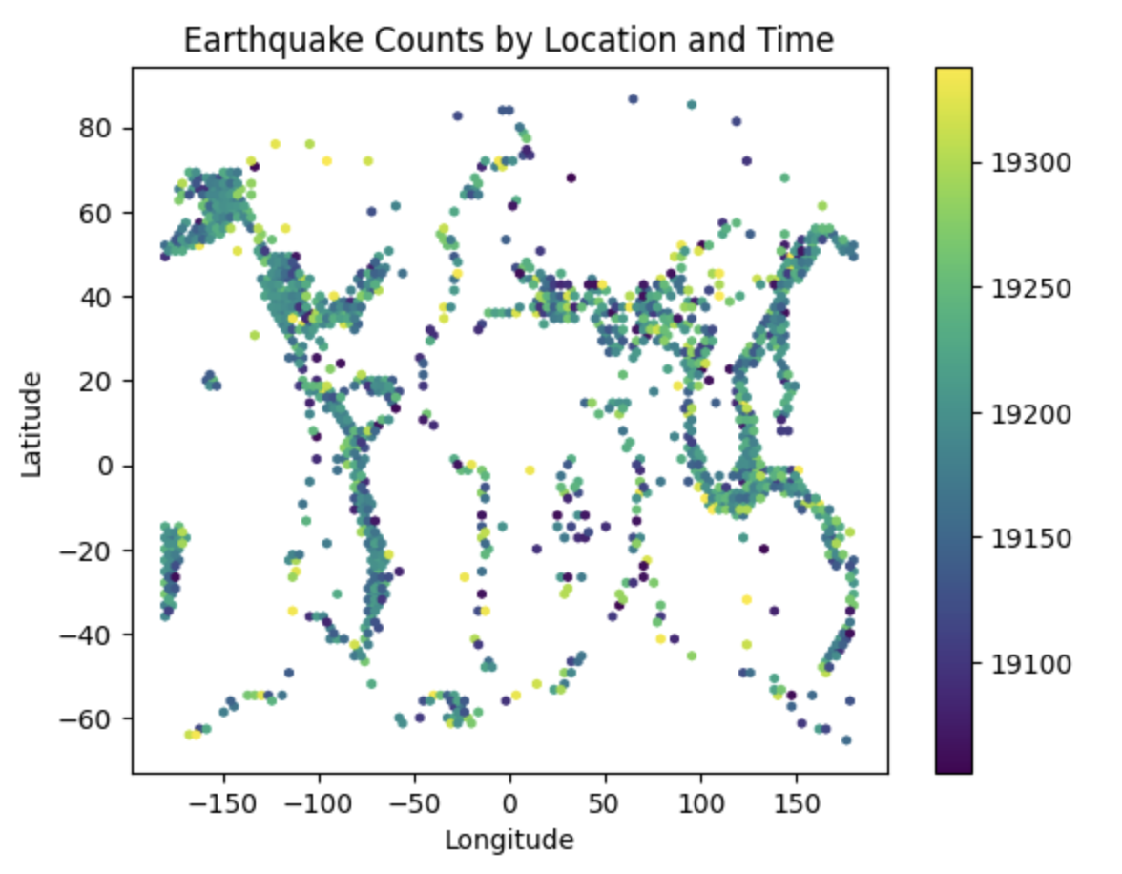Dealing with null values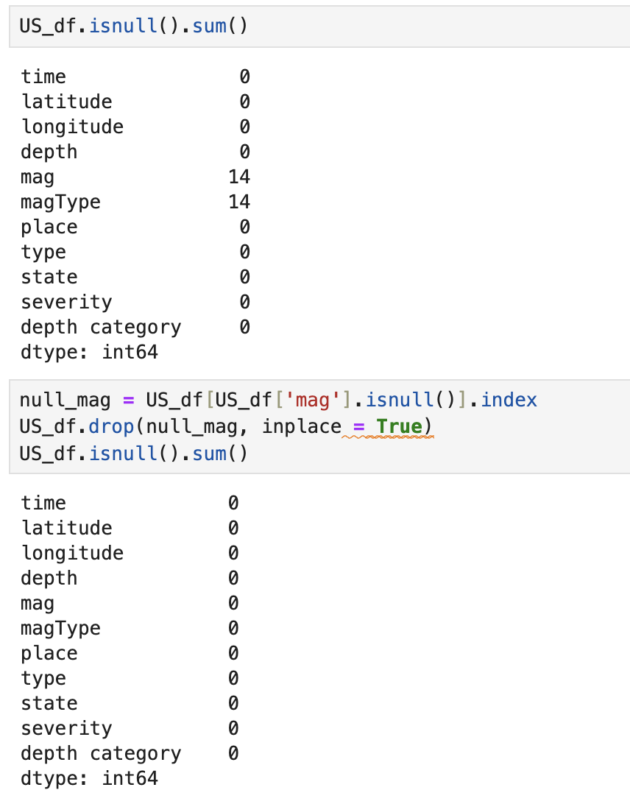

Original and changed values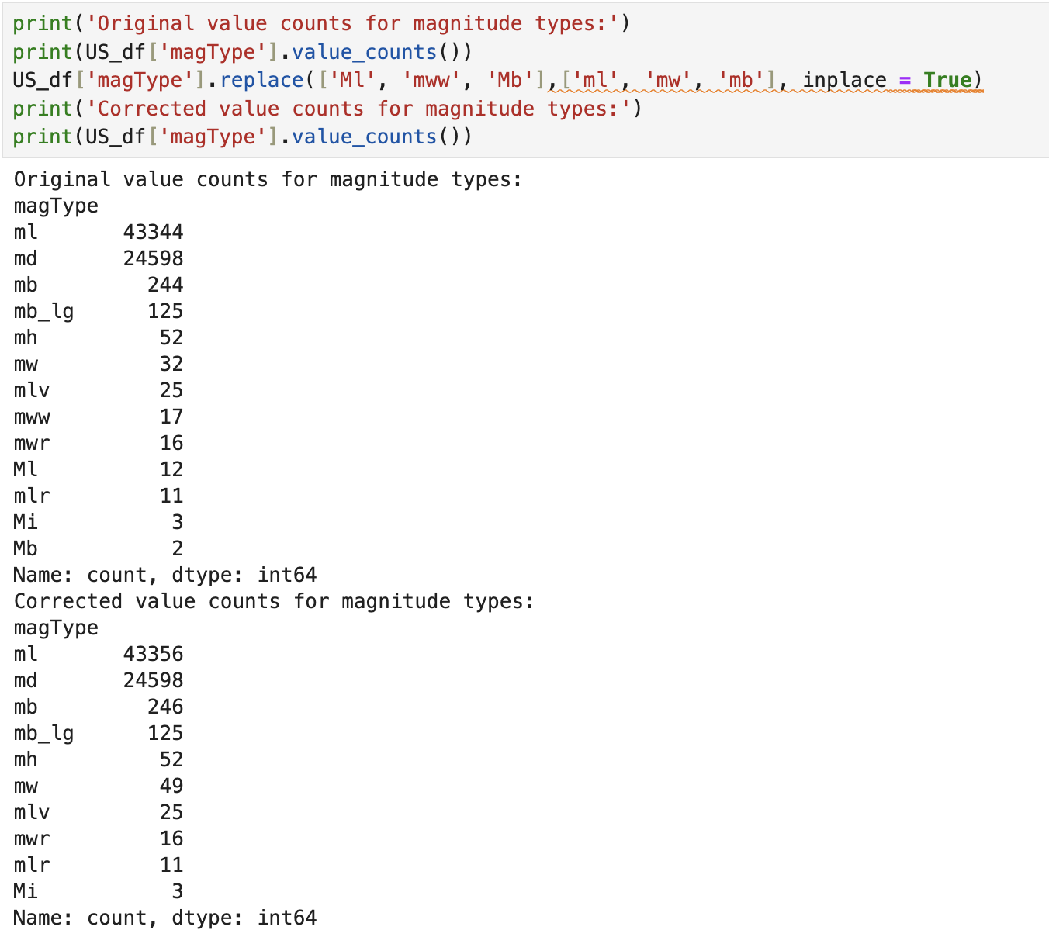State vs count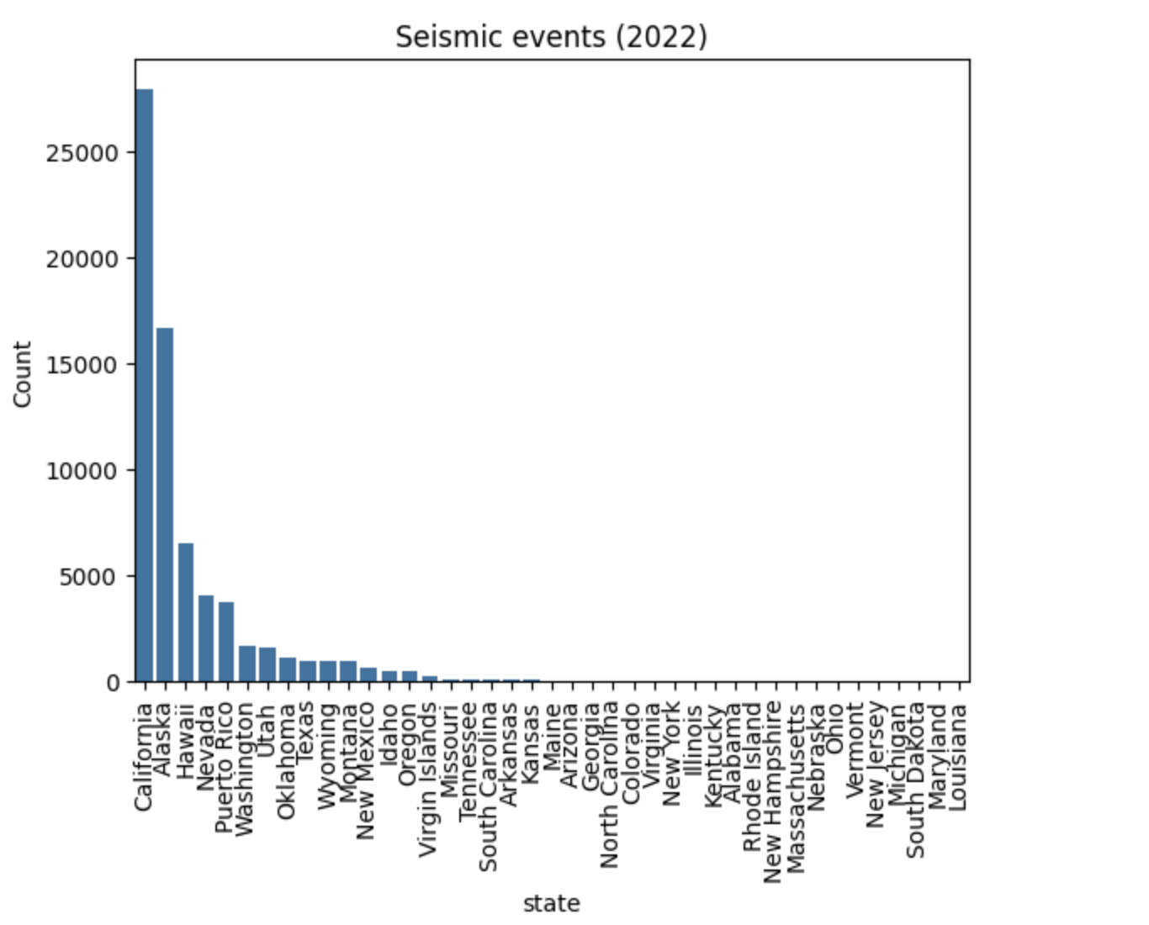States count on a log scale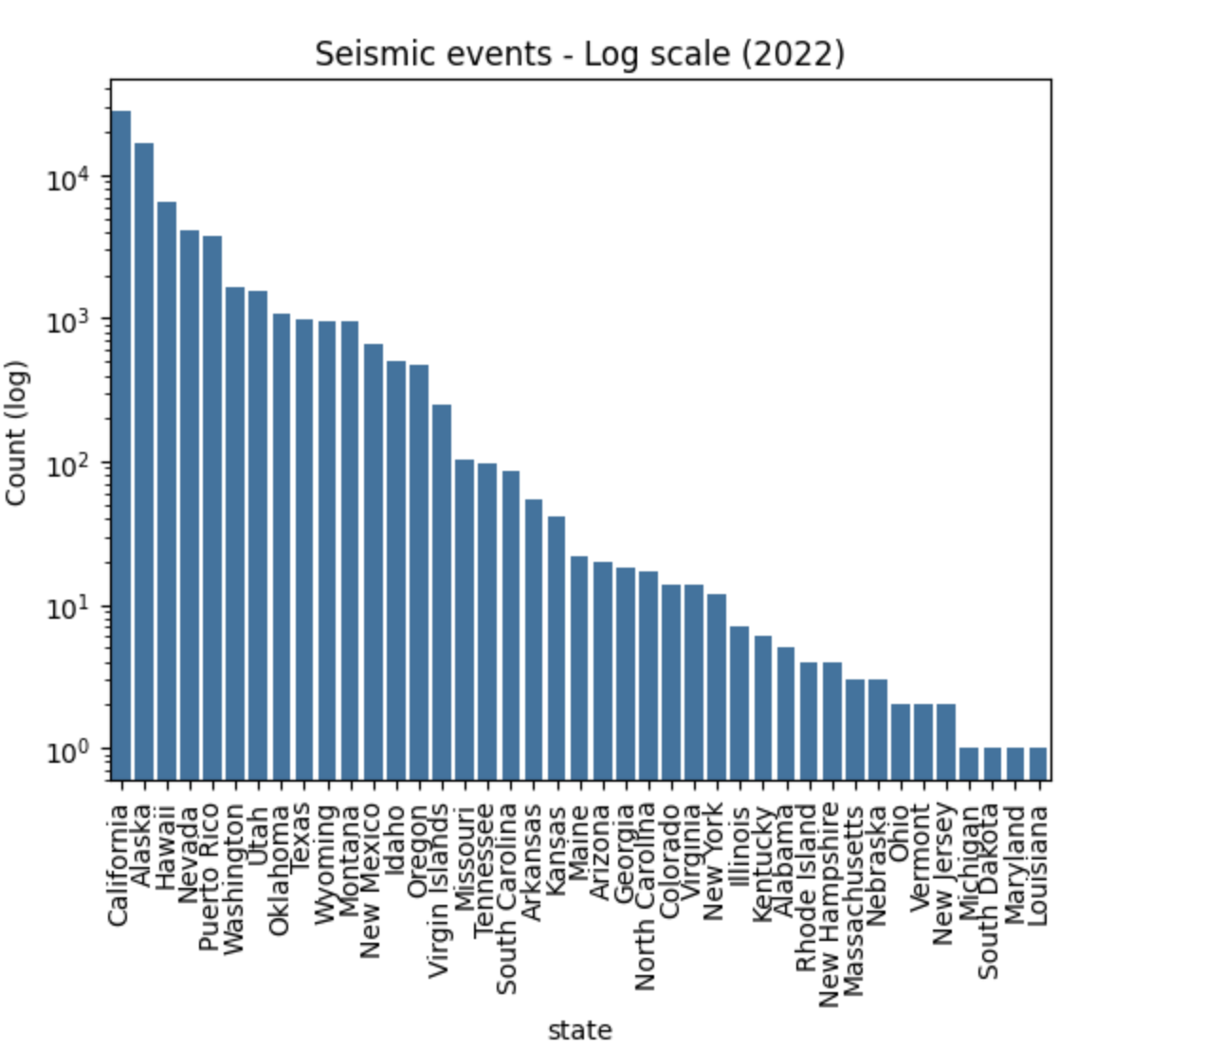Earthquake count in year 2022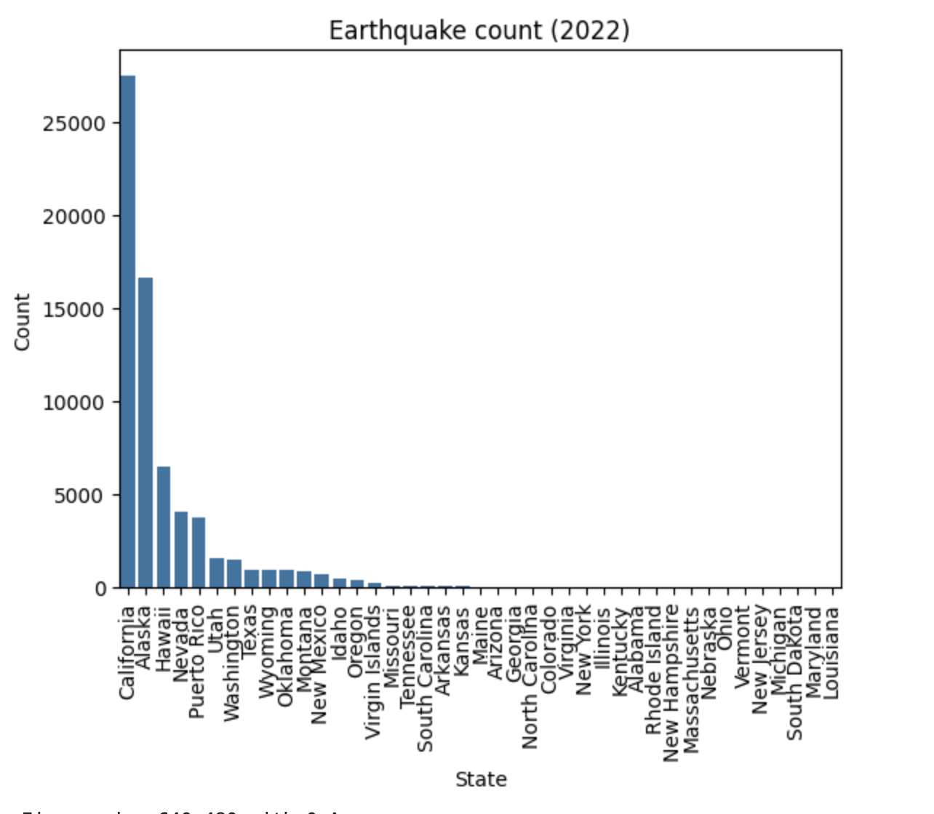States with highest magnitude of earthquakes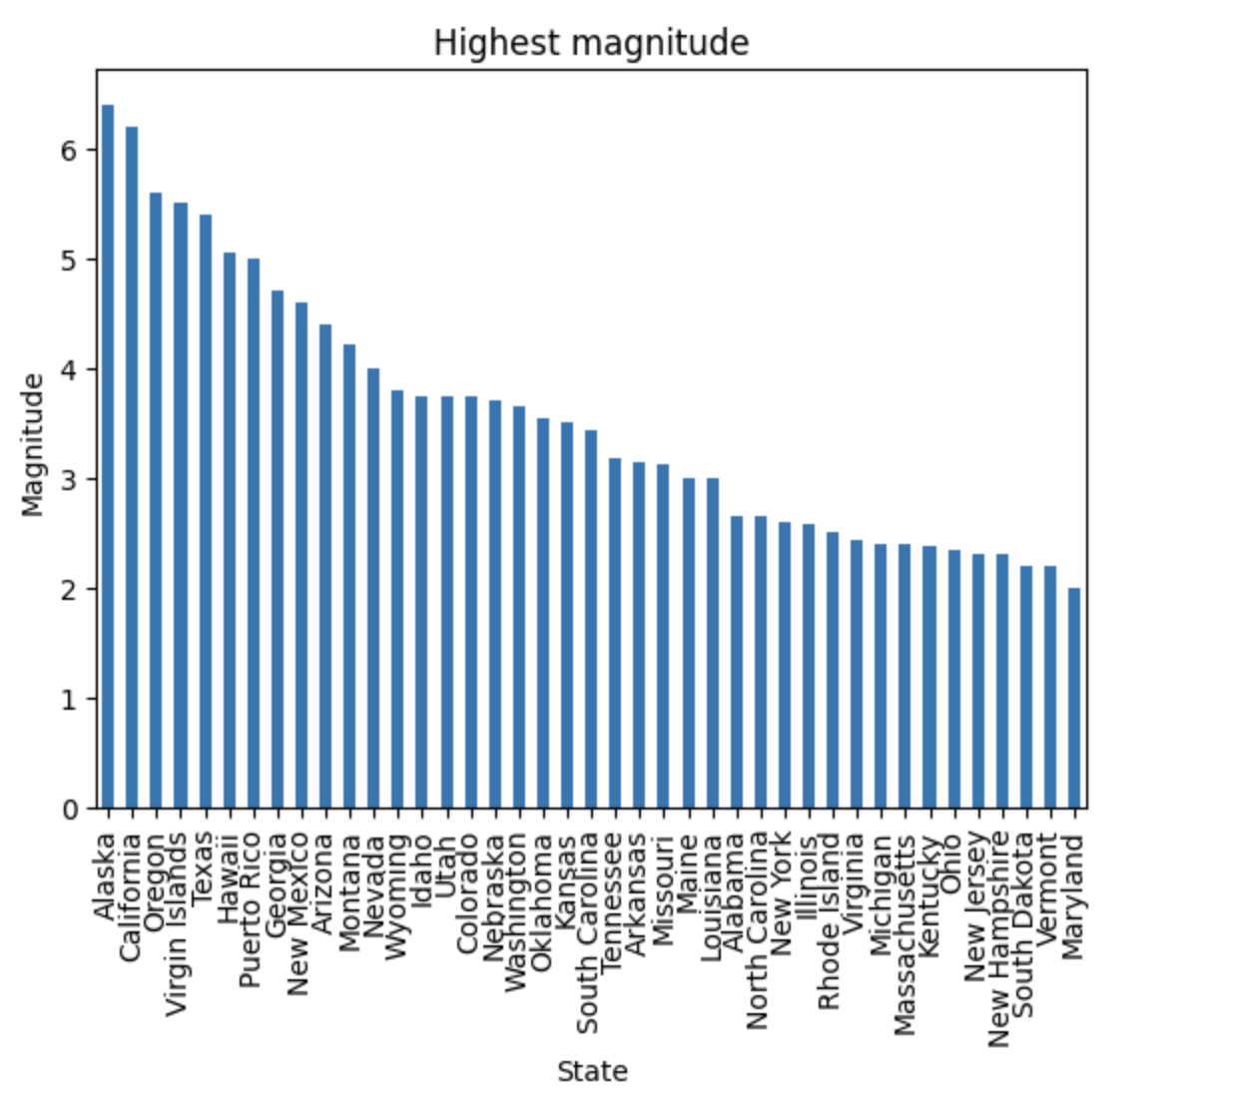States with less number of earthquakes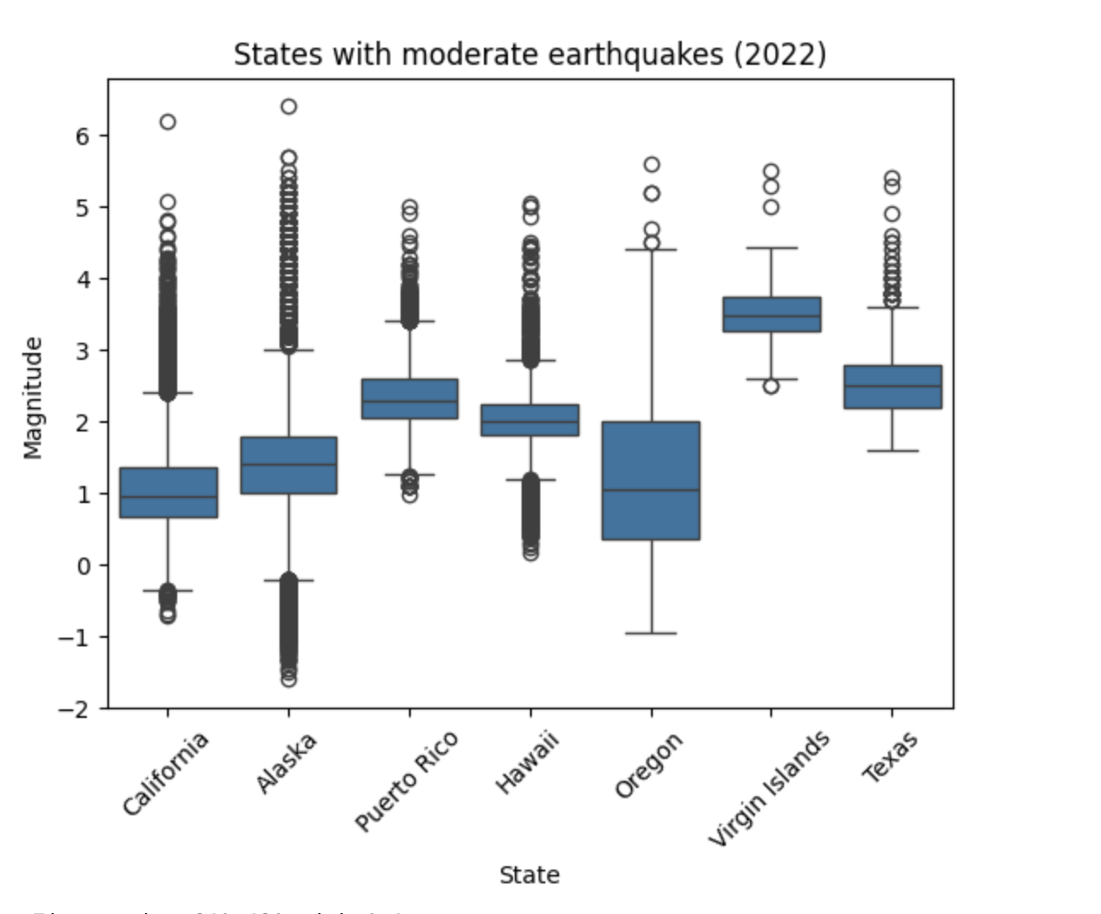Severity of earthquakes compared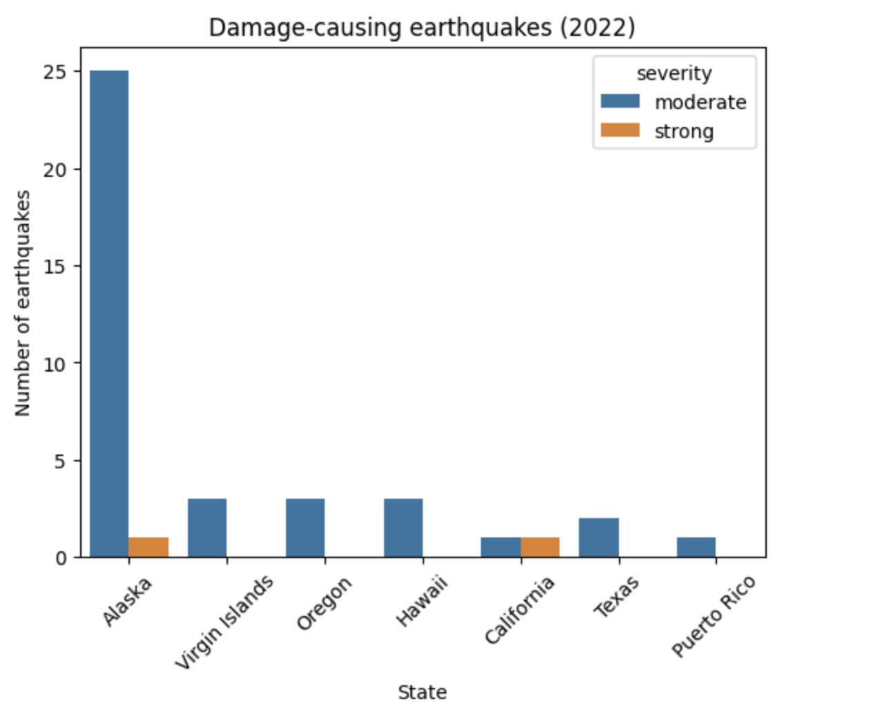Earthquakes in Alaska earthquakes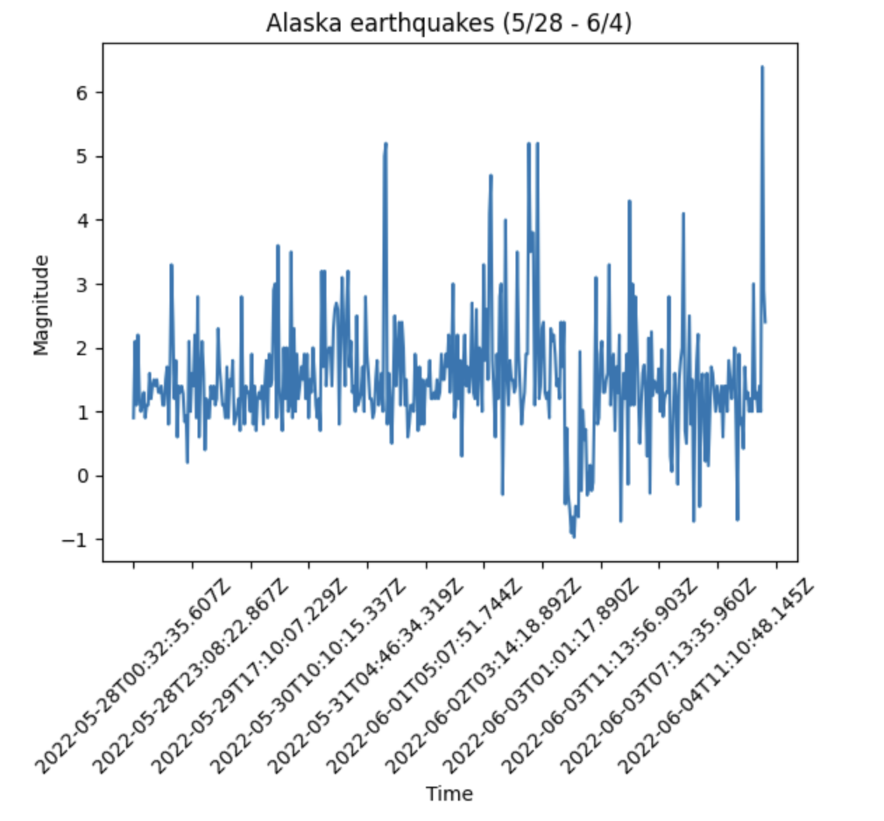Average and other metrics of California earthquake Alaska seismic events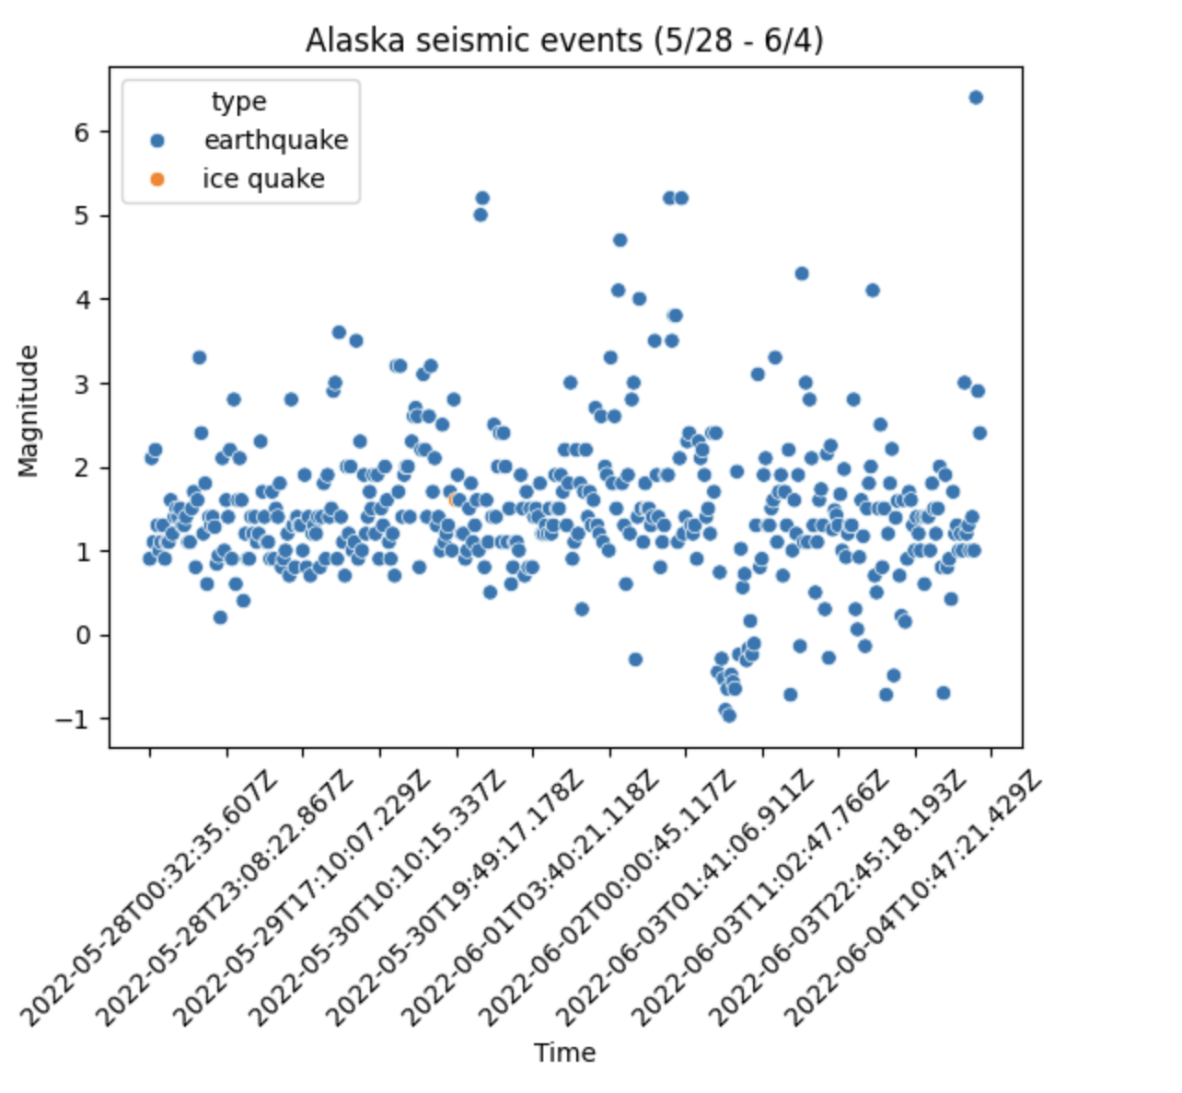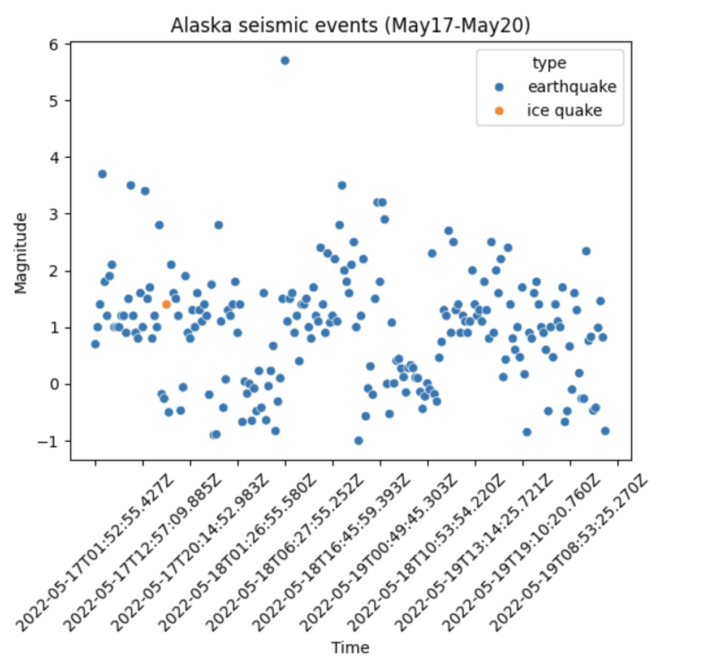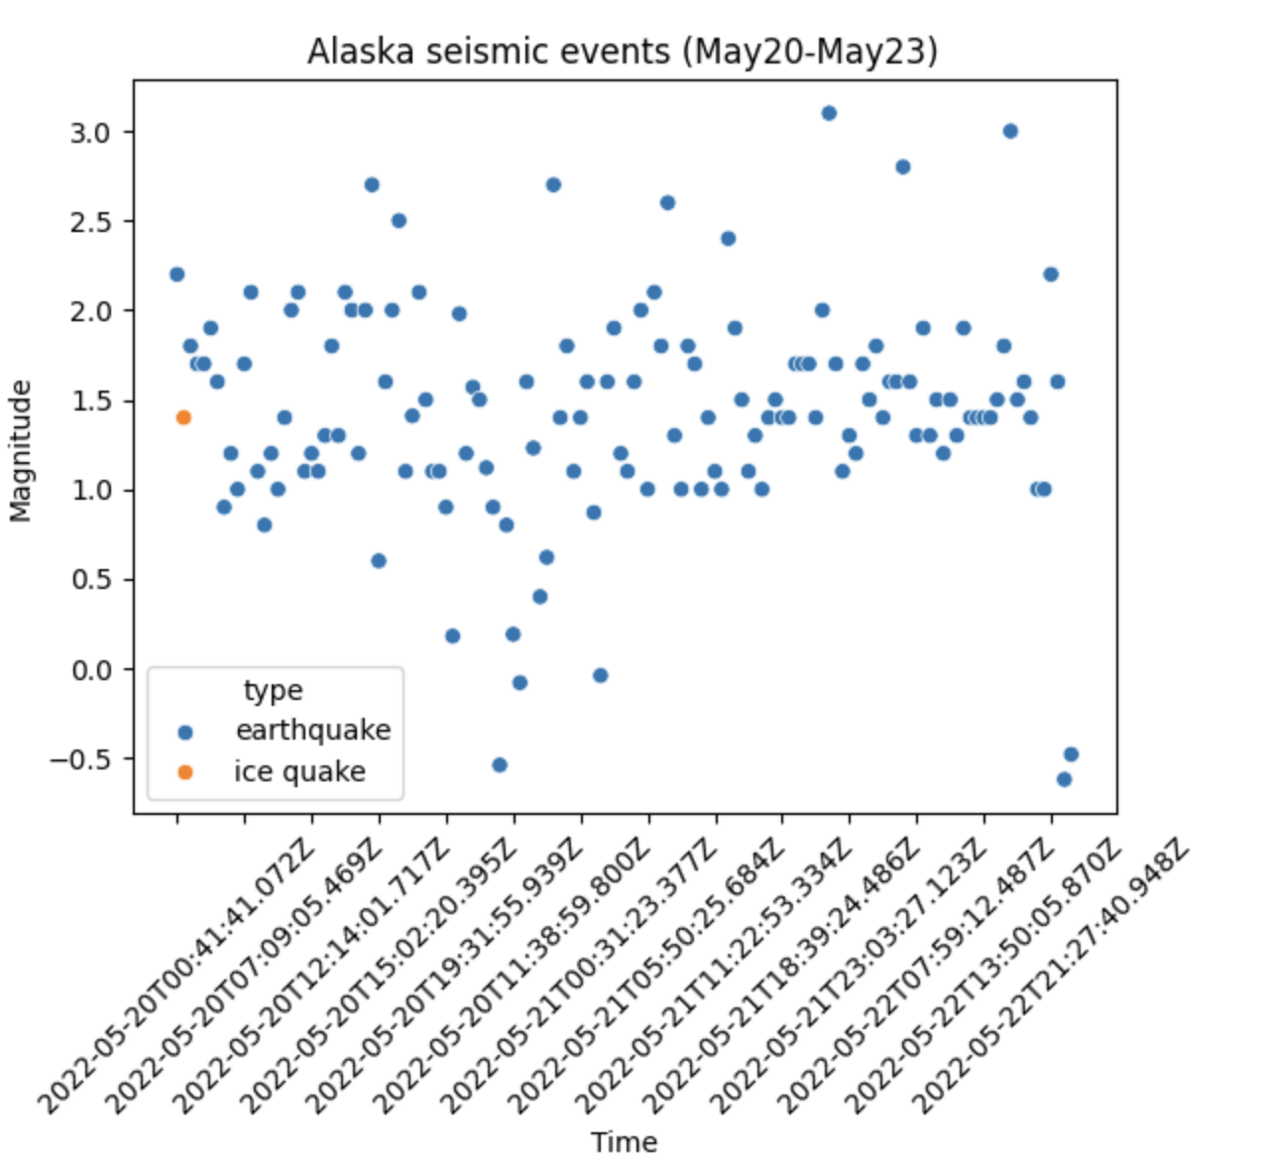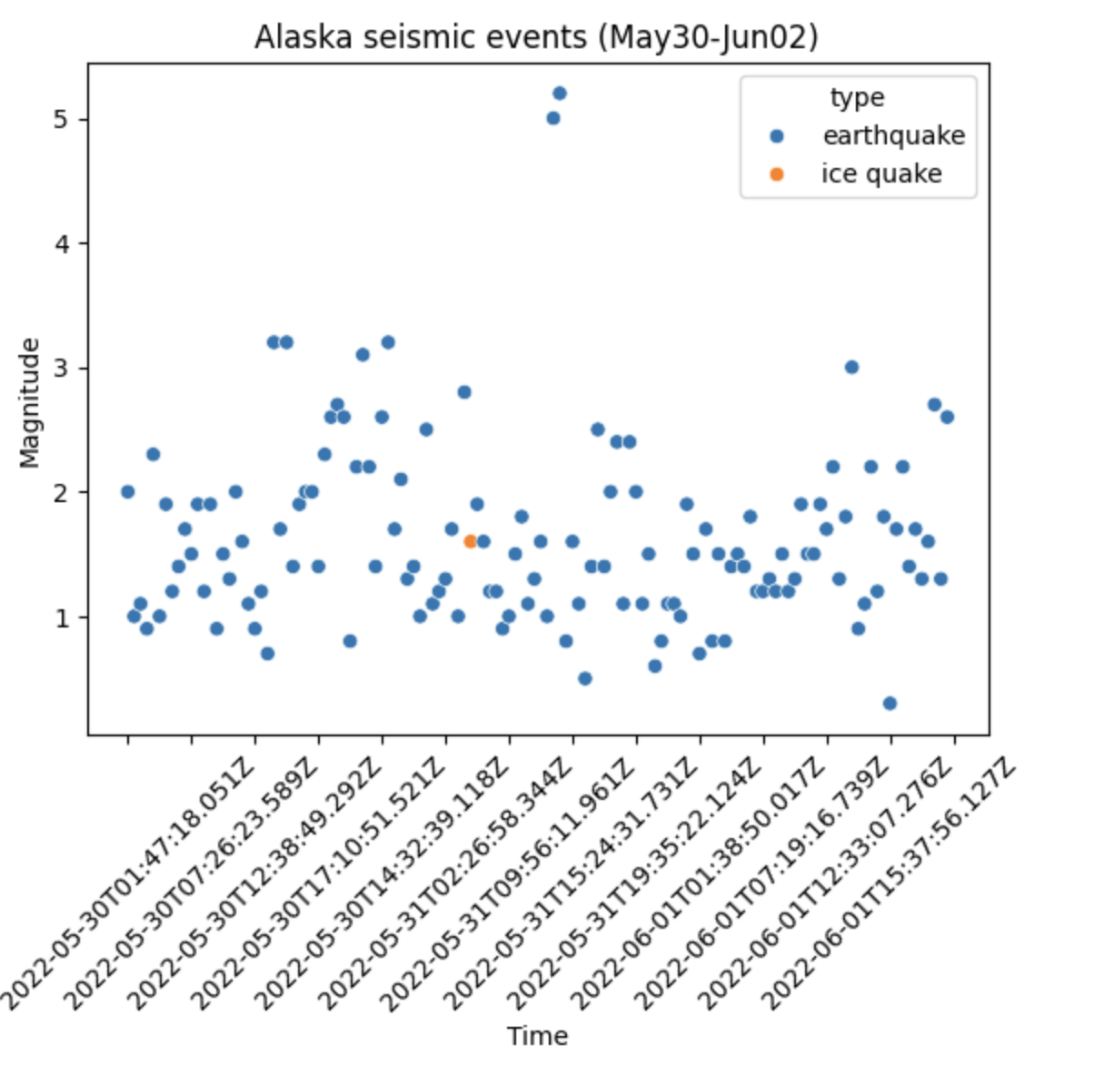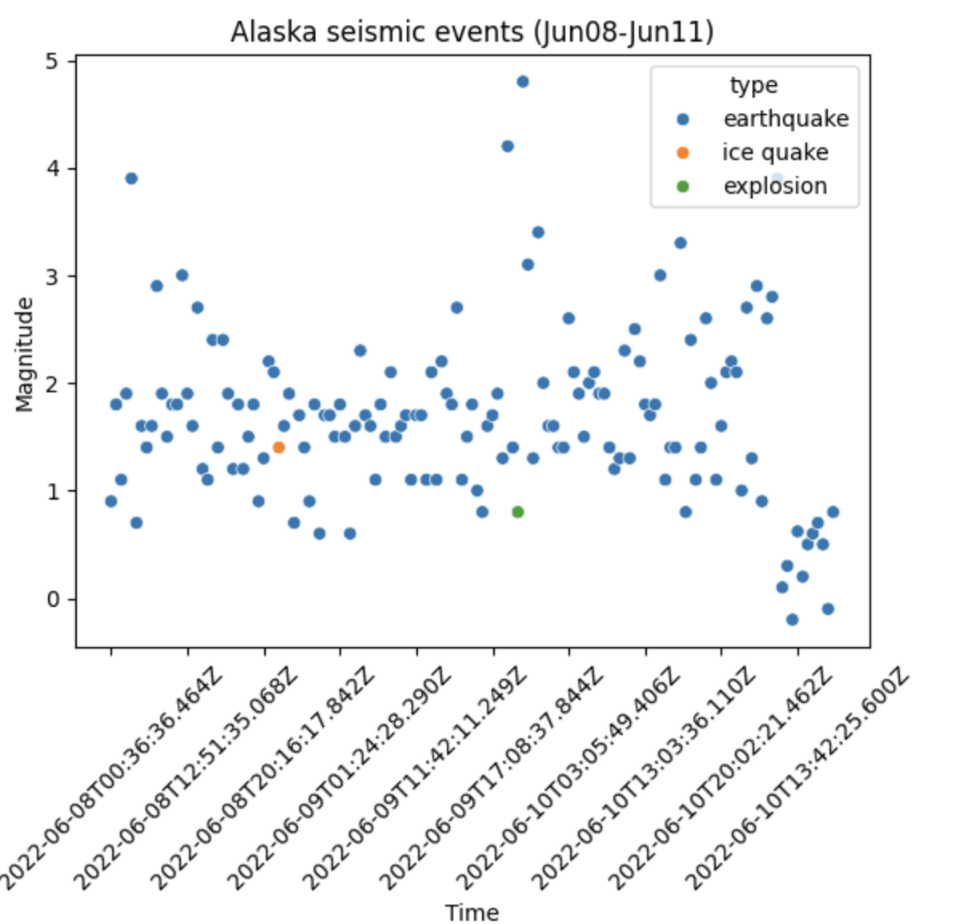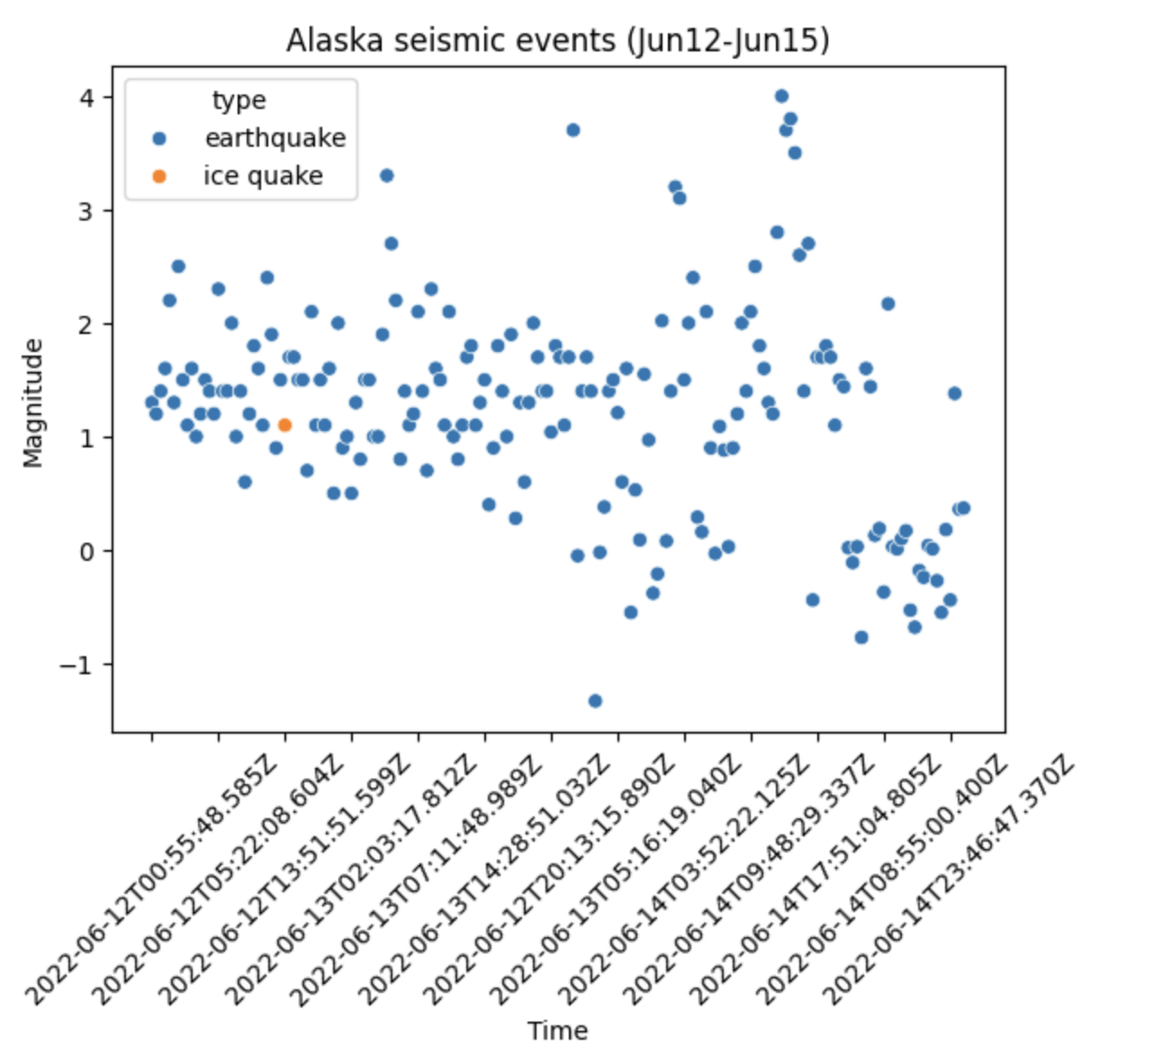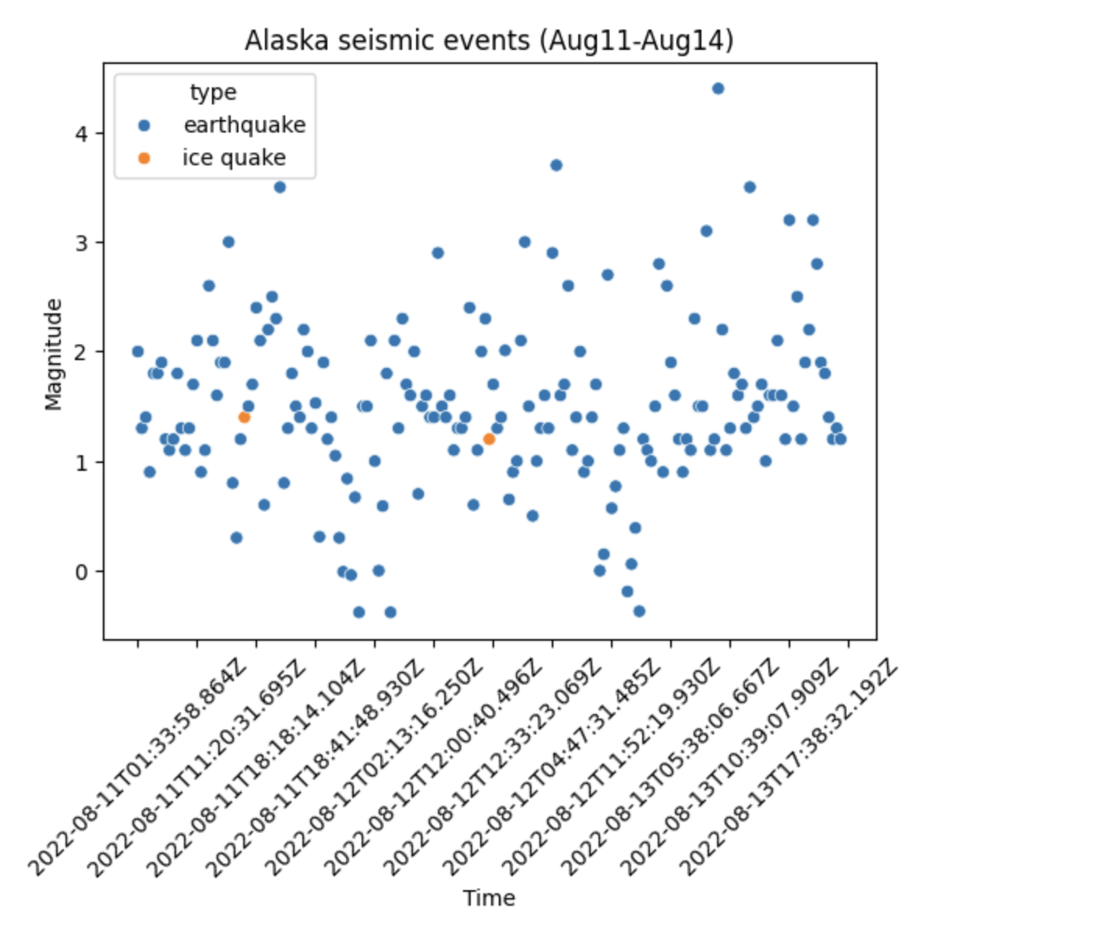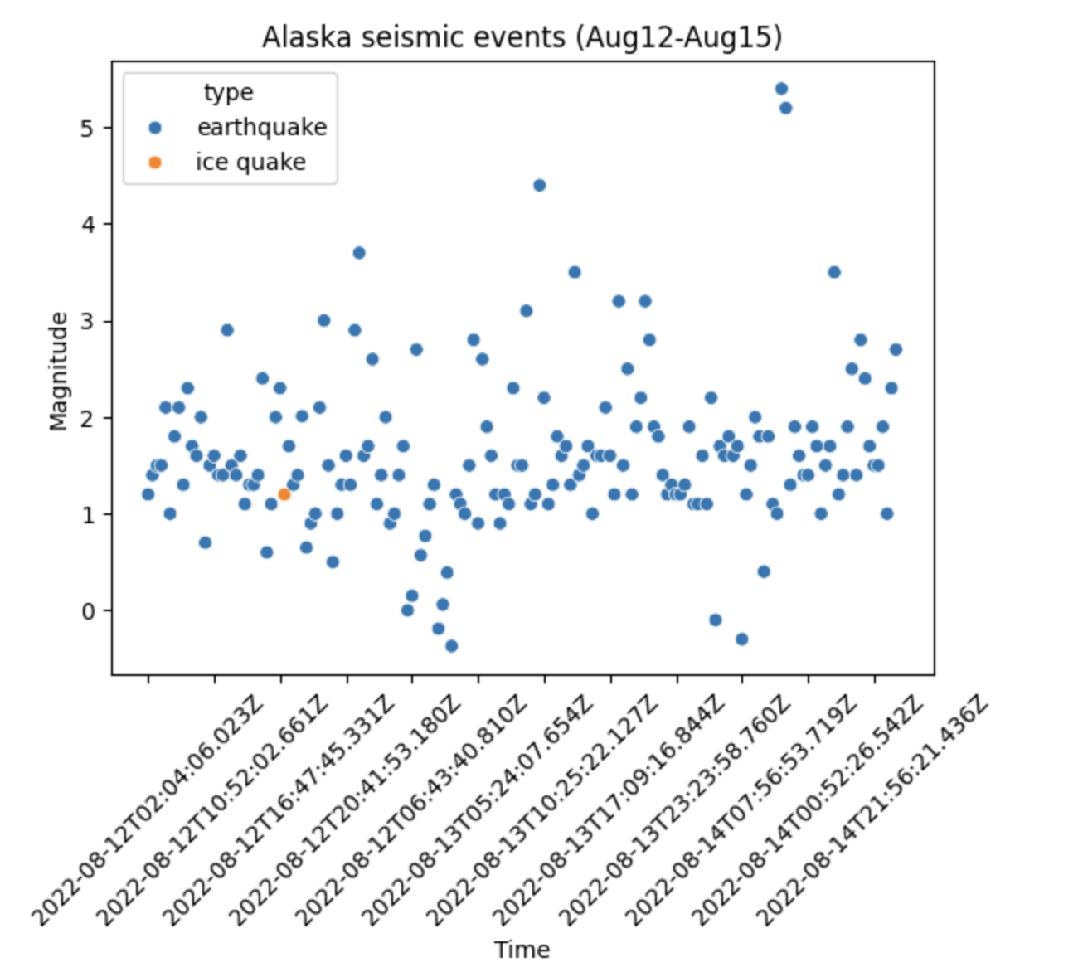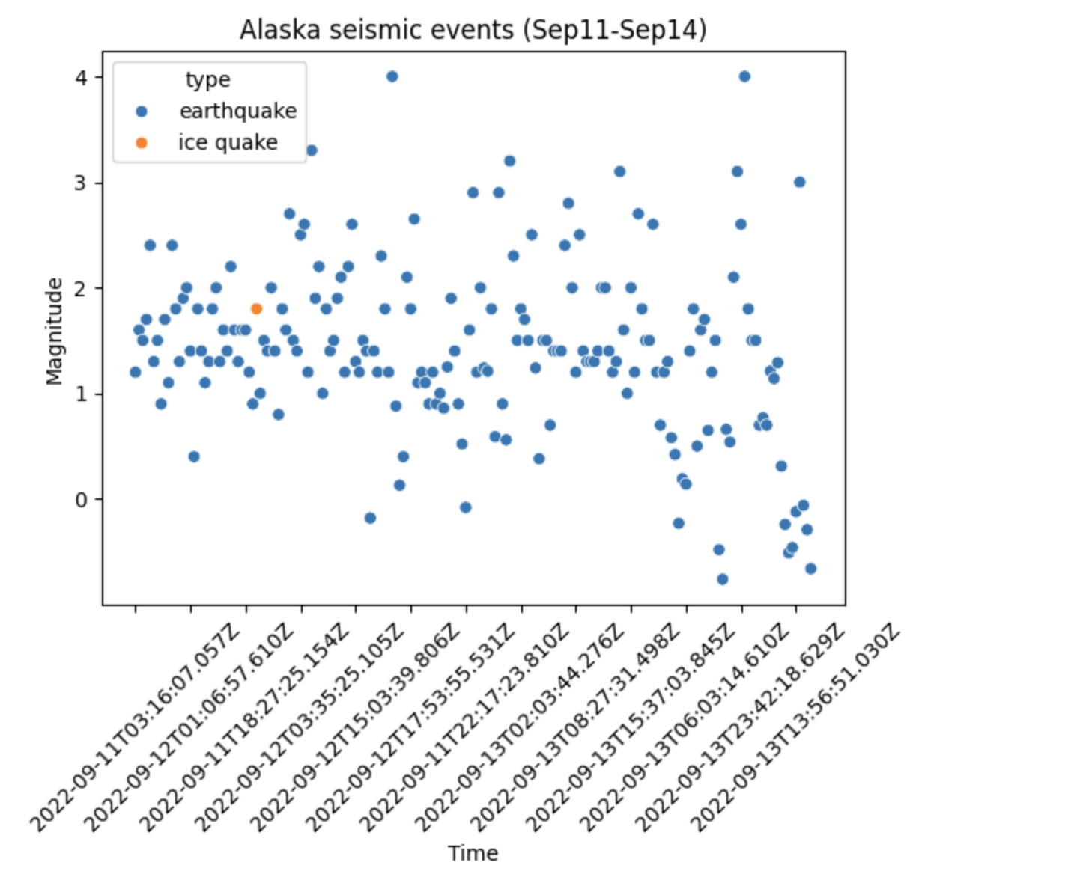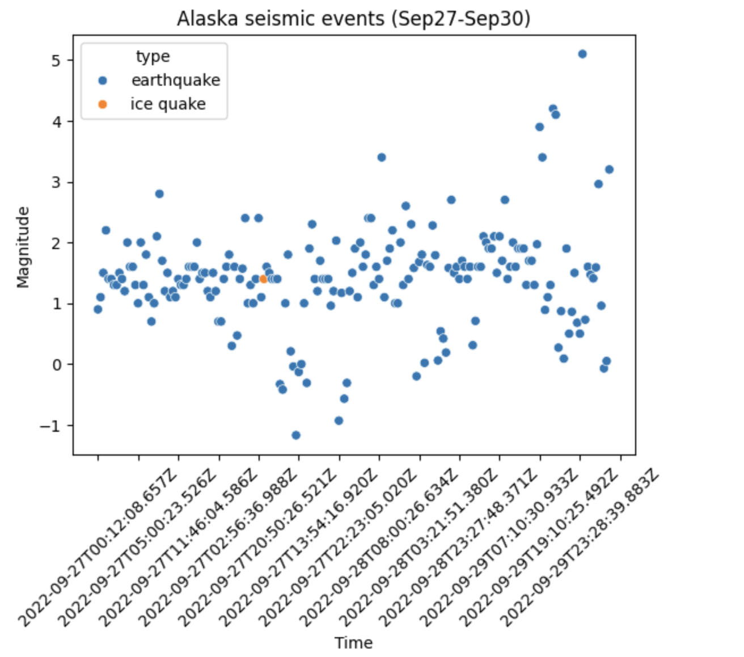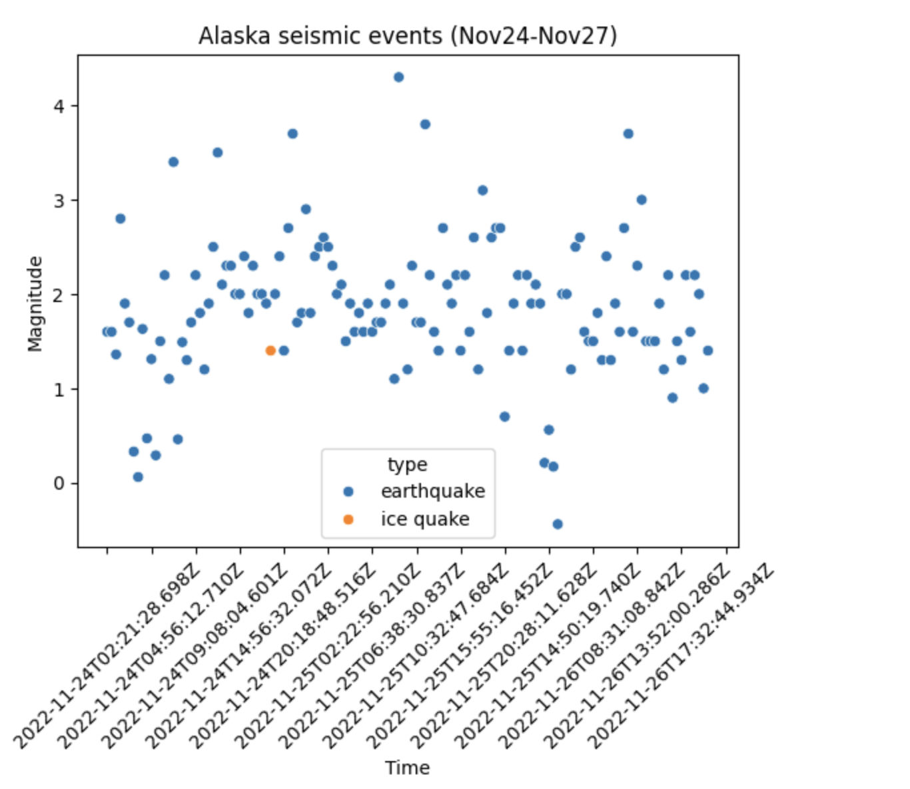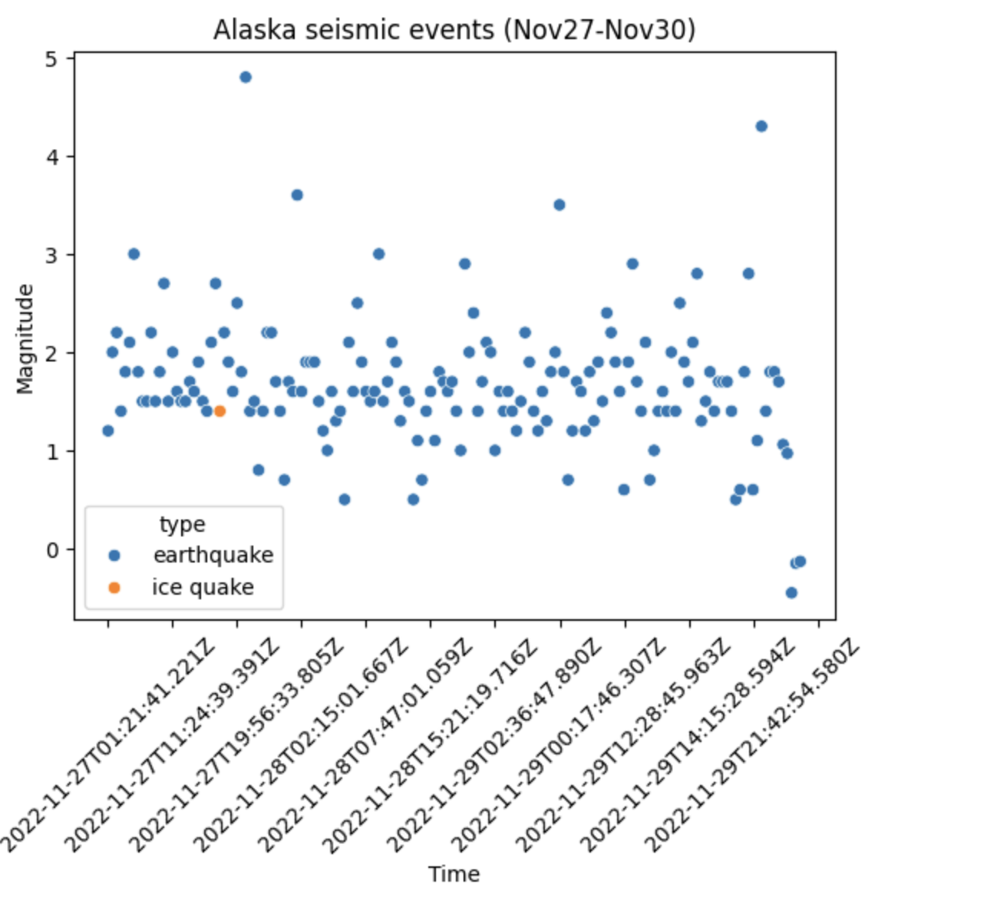Saved png files into d3 from jupyter hub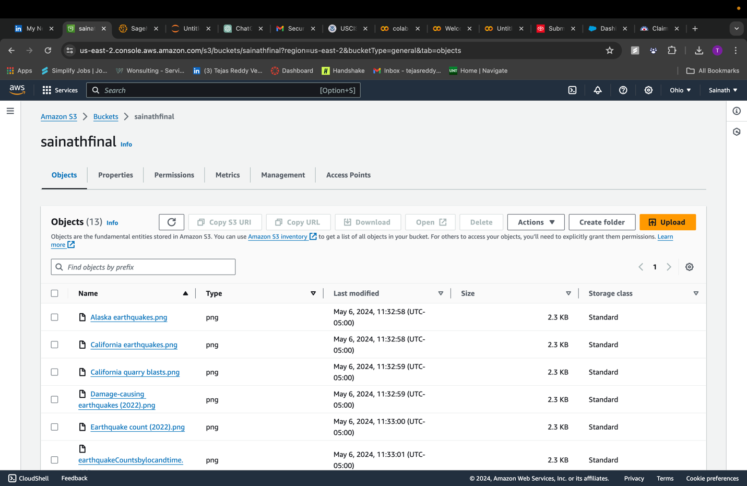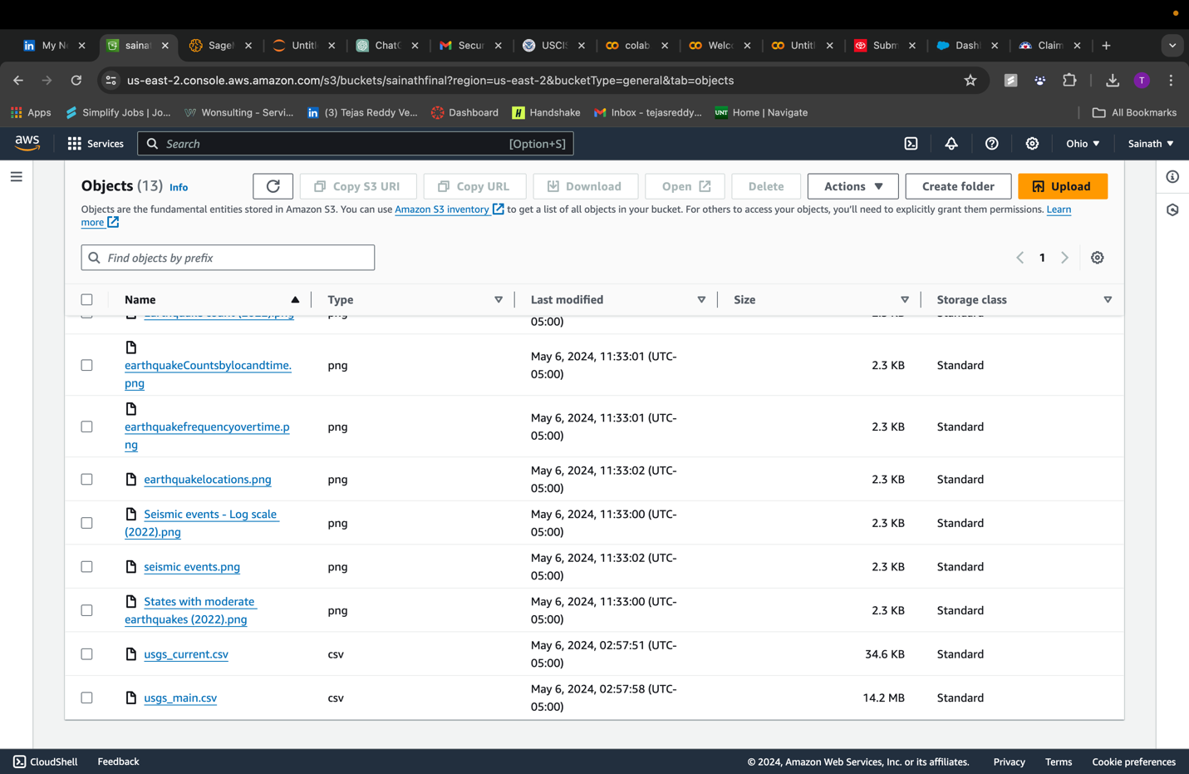

**Conclusion:**

This project successfully demonstrated how to use cloud technologies to handle and analyze massive amounts of seismic data to forecast earthquake features using PySpark and AWS SageMaker. This project not only improved our capacity to anticipate natural disasters but also showed the scalability and real-time data processing advantages of cloud computing. Among the things that have been acquired are the value of properly preparing data and the advantages of incorporating real-time data analysis for quick reaction. Subsequent research efforts could investigate the integration of more diverse data sources and sophisticated machine learning models to strengthen prediction precision and broaden the project's relevance to alternative disaster situations.

**References:**

1. Jordan, M. I., & Mitchell, T. M. (2015). Machine Learning: Trends, Perspectives, and Prospects. Science, 349(6245), 255-260.
2. Zaharia, M., Chowdhury, M., Franklin, M. J., Shenker, S., & Stoica, I. (2016). Apache Spark: A Unified Engine for Big Data Processing. Communications of the ACM, 59(11), 56-65.
3. Liaw, A., & Wiener, M. (2002). Classification and Regression by randomForest. R News, 2(3), 18-22. Retrieved from <https://CRAN.R-project.org/doc/Rnews/>
4. Stein, S., & Wysession, M. (2003). An Introduction to Seismology, Earthquakes, and Earth Structure. Blackwell Publishing.